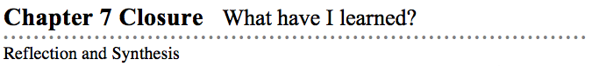
1. SUMMARIZING MY UNDERSTANDING
This section gives you an opportunity to show what you know about certain math topics or ideas. In this case, you will be solidifying some of your ideas about slope.
Obtain the Chapter 7 Closure GO Resource Page from your teacher. Follow the directions below to demonstrate your understanding of slope.
Part 1: Answer the question provided in each section of the Slope GO. On the resource page, work with your team to write six “Who, What, When, Where, Why, How?” questions about slope.
Part 2: Follow your teacher’s directions to pair up with students in another team and trade GO questions to answer.
Part 3: Be ready to contribute your team’s ideas to a class discussion. On your own paper, make note of new ideas about slope.

Name:
Date:
Unit 7 Closure Homework

WHAT HAVE I LEARNED?
Doing the problems in this section will help you to evaluate which types of problems you feel comfortable with and which ones you need more help with.
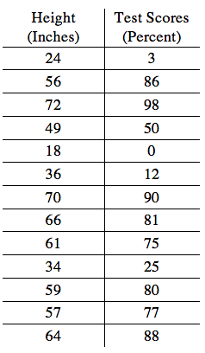
Solve each problem as completely as you can. The table at the end of this closure section provides answers to these problems. It also tells you where you can find additional help and where to find practice problems like them.
- CL 7-116. Graph the following data on a scatterplot.
  - Does the graph show either a positive or a negative association?

  - Does there appear to be a connection between height and spelling ability?

  - Does greater height cause better spelling ability?

  - What other factors could create the association you see?

- CL 7-117. Complete the table and find the rule.
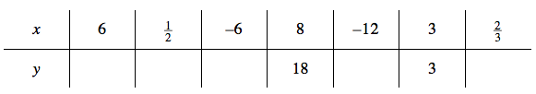

- CL 7-118. For the following examples, tell whether there is positive association, negative association, or no association.
  - The number of inches of rain per hour and the height of water in a reservoir.
  - The amount of food a person eats and how many pets he or she has.
  - The height of a tree and the amount of nutrients it gets.
  - The number of hours spent hiking in the mountains and the amount of water left in your water bottle.

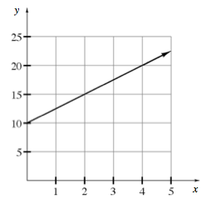
CL 7-119. Answer the following question for the graph at right.
  - What is the slope of the line?

  - What is the y-intercept?

  - Write a rule for the line.

CL 7-120. Solve the following equations.

  - 0.75x − 0.5 = x + 1.5

  - x − 2 = −$\frac{1}{6}$x + $\frac{1}{3}$

  - 3(x + 2) − 3 = 3x – 2

  - 5(x − 1) = 5(2x − 3)

CL 7-121. Ryan and Janelle are driving from different locations to meet at Mammoth Lakes. When they each stopped for lunch, they called each other on their cell phones. Ryan had traveled 245 miles in 3$\frac{1}{2}$ hours. Janelle had driven 260 miles in 4 hours.
  - How fast was each person driving?

  - If Janelle originally started 575 miles from Mammoth Lakes and continues traveling at the same rate (from part (a)), how many more hours will it take her to arrive at her destination?

CL 7-122. Graph a line that goes through the points (−2,1) and (4,−2) .
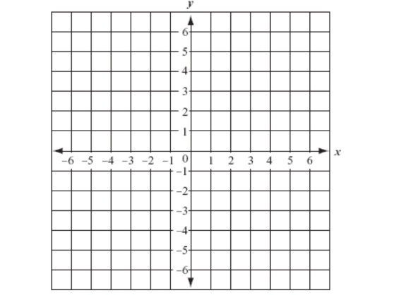
  - What is the slope of the line?

  - Graph a line that is parallel to this line. What is the slope of the parallel line?

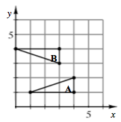
CL 7-123. Describe a set of transformations that will move Triangle A on the graph at right to match up with Triangle B.

- CL 7-124. For each of the problems above, do the following:
  - Draw a bar or number line that represents 0 to 10.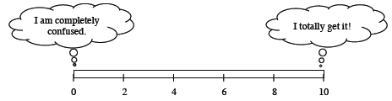
  - Color or shade in a portion of the bar that represents your level of understanding and comfort with completing that problem on your own.
- If any of your bars are less than a 5, choose one of those problems and complete one of the following tasks:
  - Write two questions that you would like to ask about that problem.
  - Brainstorm two things that you DO know about that type of problem.
- If all of your bars are a 5 or above, choose one of those problems and do one of these tasks:
  - Write two questions you might ask or hints you might give to a student who was stuck on the problem.
  - Make a new problem that is similar and more challenging than that problem and solve it.

