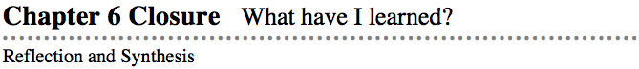
The activities below offer you a chance to reflect about what you have learned during this chapter. As you work, look for concepts that you feel very comfortable with, ideas that you would like to learn more about, and topics you need more help with.

1. SUMMARIZING MY UNDERSTANDING
This section gives you an opportunity to show what you know about certain math topics or ideas. Your teacher will give you specific directions for exactly how to do this and will provide you with instructions about how to summarize your understanding of transformations and undoing transformations. In this activity, you will use a triangle to review transformations.
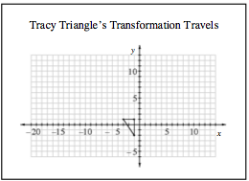
Predict and Order: Predict how each transformation will change or move the shape. Select an order for the four transformations and predict what the new coordinates of the vertices will be after each step.
Apply Transformations: Follow the transformation steps you described on the graph. Use color and written descriptions to show how each transformation alters the shape and its position on the coordinate graph. Check that the coordinates you predicted were correct.
Tracy Triangle’s  Transformative Travels  Add 5 to each x-coordinate. | Tracy Triangle’s  Transformative Travels  Multiply each y-coordinate by −1
Tracy Triangle’s  Transformative Travels  Multiply each coordinate by 2. | Tracy Triangle’s  Transformative Travels  Add −8 and then 3 to each x-coordinate.  Add 9 and −4 to each y-coordinate.
Undo Transformations: To get the triangle back to the original position, undo your transformations. You may choose to undo each transformation step or to find a new series of steps to return the shape to its original position. Using color, symbols, and written descriptions, show how each transformation changes the shape’s size and position on the coordinate graph.

Name:
Date:
Unit 6 Closure Homework

WHAT HAVE I LEARNED?
Doing the problems in this section will help you to evaluate which types of problems you feel comfortable with and which ones you need more help with.
- CL 6-110. Priscilla and Ursula went fishing. Priscilla brought a full box of 32 worms and used one worm every minute. Ursula brought a box with five worms and decided to dig for more before she began fishing. Ursula dug up two worms per minute. When did Priscilla and Ursula have the same number of worms? Show how you know.

- CL 6-111. Complete each list of transformation steps you could use to move triangle B back to where it started at position A, and show each transformation on your graph.
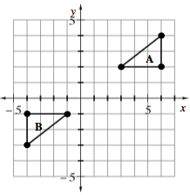
List I  1. Rotate triangle B 180° about point (−1,−1)  2. ? | List II  1. Reflect triangle B across the y-axis.  2. ?  3. ?

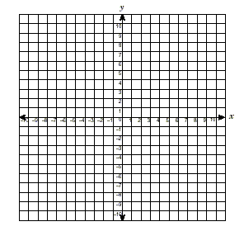
- CL 6-112. Neatly graph the points (−2,9), (−3,7) and (−5,10) on a four-quadrant graph. Connect them to make a triangle. Then, for each transformation described below:
  - Write and simplify an expression to find the new coordinates.
  - Check your answer on your graph.
  - Slide the triangle right 4 units and down 6 units.
  - Reflect the triangle across the y-axis.

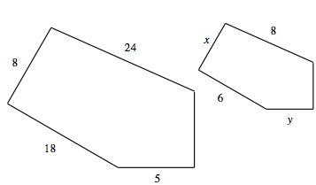
CL 6-113. The shapes at right are similar.
  - What is the scale factor?

  - Find the sides labeled x and y.

CL 6-114. As Khan and Jorman practice for college entrance tests, their scores increase. Khan’s current score is 750 and is rising 8 points per week. Jorman’s current score is 650 but is growing by 30 points per week. Write an equation or system of equations to determine when Jorman will catch up with Kahn. Be sure to define your variable(s).

CL 6-115. Solve each equation.
- 3(2 + x) = 4 − (x − 2) b. 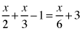

CL 6-116. Samantha is dilating triangle ABC at right. She multiplied each x-coordinate and y-coordinate of triangle ABC by −2.
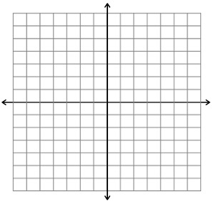
  - Graph Samantha’s new triangle.
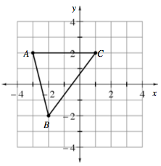
  - Describe how triangle ABC changed.

CL 6-117. A trapezoid has a perimeter of 117 cm. The two shortest sides have the same length. The third side is 12 cm longer than one short side. The final side is 9 cm less than three times one short side. How long is each side of the trapezoid?
- Define a variable and write an equation to represent this problem. Solve your equation and write your answer in a complete sentence.

- CL 6-118. For each of the problems above, do the following:
  - Draw a bar or number line that represents 0 to 10.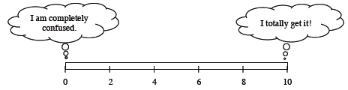
  - Color or shade in a portion of the bar that represents your level of understanding and comfort with completing that problem on your own.
- If any of your bars are less than a 5, choose one of those problems and complete one of the following tasks:
  - Write two questions that you would like to ask about that problem.
  - Brainstorm two things that you DO know about that type of problem.
- If all of your bars are a 5 or above, choose one of those problems and do one of these tasks:
  - Write two questions you might ask or hints you might give to a student who was stuck on the problem.
  - Make a new problem that is similar and more challenging than that problem and solve it.

