Name:
Date:

Unit 4 Review
Doing the problems in this section will help you to evaluate which types of problems you feel comfortable with and which ones you need more help with.
Solve each problem as completely as you can. The table at the end of this closure section provides answers to these problems. It also tells you where you can find additional help and where to find practice problems like them.

- CL 4-72. Examine the pattern below, and then complete parts (a) through (f) that follow.
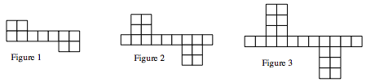
  - On graph paper, sketch Figure 0 and Figure 4.
  - Make a table showing Figure 0 through Figure 4.

  - Write a rule to represent the pattern.

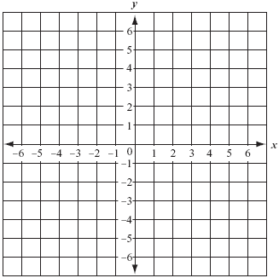
  - On graph paper, create a graph of the number of tiles in each figure.

  - What is the growth for the pattern?

  - Predict how many tiles Figure 100 will have.

- CL 4-73. Are the two expressions below equal? Show how you know.
4x² + 2x − 5 − 3x and 6x² − x + 3 − 2x² – 8

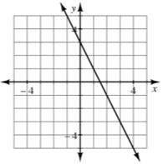
- CL 4-74. Examine the graph at right.
  - Give two ways you can tell that the rule y = 2x − 3 does not match the graph.

  - Make a graph that matches the rule y = 2x − 3.

  - Find a rule that represents the graph at right.

- CL 4-75. Consider the rule y = 5x + 7.
  - How many tiles are in Figure 0?

  - Which figure has 37 tiles?

  - In the equation y = mx + b, what do the letters m and b represent?

- CL 4-76. Molly read 75 pages of the latest thriller mystery novel in 45 minutes. What is her unit rate? At the same rate, how long will it take her to read the entire 425-page novel?

- CL 4-77. Solve this equation to find x: 2 - (3x - 4) = 2x - 9.

- CL 4-78. Simplify the following expressions, if possible.

  - x + 4x − 3 + 3x² − 2x

  - 2x + 4y² − 6y² − 9 − x + 3x

  - 3x² + 10y − 2y² + 4x −14

  - 20 + 3xy − 4xy + y² + 10 − y²

  - Evaluate the expressions in parts (a) and (b) above when x = 5 and y = −2.
- CL 4-79. Copy and complete the table for the linear pattern below.
IN (x) | −4 | −3 | −2 | −1 | 0 | 1 | 2 | 3 | 4
OUT (y) |  |  |  |  | −2 | 3 | 8

  - What is the y-intercept? What is the pattern of growth?

  - Find the rule for this line.

  - If the output number (y) is −52, what was the input number (x)?

- CL 4-80. For the problem below, define a variable, write an equation, and solve it. Use the 5-D Process, if needed, to help you set up your equation.
For the school play, the advance tickets cost $3, while tickets at the door cost $5. Thirty more tickets were sold at door than in advance, and $2630 was collected. How many of each kind of ticket were sold? Write your answer in a sentence.

- CL 4-81. For each of the problems above, do the following:
  - Draw a bar or number line that represents 0 to 10.
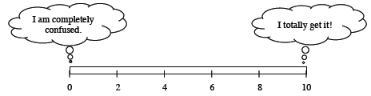
  - Color or shade in a portion of the bar that represents your level of understanding and comfort with completing that problem on your own.
- If any of your bars are less than a 5, choose one of those problems and complete one of the following tasks:

  - Write two questions that you would like to ask about that problem.
  - Brainstorm two things that you DO know about that type of problem.
- If all of your bars are a 5 or above, choose one of those problems and do one of these tasks:
  - Write two questions you might ask or hints you might give to a student who was stuck on the problem.
  - Make a new problem that is similar and more challenging than that problem and solve it.

