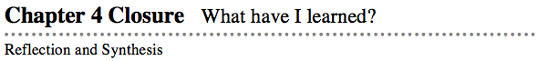
The activities below offer you a chance to reflect about what you have learned during this chapter. As you work, look for concepts that you feel very comfortable with, ideas that you would like to learn more about, and topics you need more help with.

1. SUMMARIZING MY UNDERSTANDING
This section gives you an opportunity to show your understanding of how to move between the different representations of a pattern (situation, table, graph, and rule), which is the main idea of this chapter.
Team Representations Poster

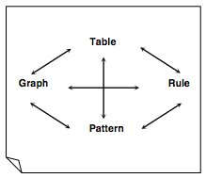
In this chapter, you have learned how to move directly from one representation to another. Now you have an opportunity to demonstrate what you know about these concepts. Today you and your team will create a poster that illustrates the skills and knowledge that you have developed in this area.

Make Connections: Follow your teacher’s instructions to work with your team to find or create problems that demonstrate all of the connections between the different representations shown in the Representations of Patterns Web.
Along with the solutions to each of your problems, you will need to explain the process involved. To give an example for every connection on the web, you will need one of each of the following:

graph → table | graph → pattern | graph → rule
table → graph | table → pattern | table → rule
pattern → graph | pattern → table | pattern → rule
rule → graph | rule → table | rule → pattern
Team Poster: Follow the model above to label and construct the sections of your poster from the pieces that your team has created. Decide together on a creative title for your poster.

