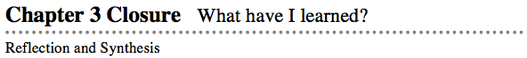
- The activities below offer you a chance to reflect about what you have learned during this chapter. As you work, look for concepts that you feel very comfortable with, ideas that you would like to learn more about, and topics you need more help with.

1. SUMMARIZING MY UNDERSTANDING
- This section gives you an opportunity to show what you know about certain math topics or ideas.
- Multiple Representations
- In this chapter, you learned about how data can be shown in one of four representations. These include a situation or tile pattern, a graphical display, a table of values, and a symbolic rule. Show what you know about these representations by doing the following activity with your team. While you have not fully investigated all of these representations so far, this exercise will prepare you to make important connections in Chapter 4.
- Pick a pattern or problem from the chapter that you think can best demonstrate your understanding of these four representations.
- Obtain a Chapter 3 Closure Resource Page: Multiple Representations GO (Graphic Organizer) from your teacher, a reduced copy of which is shown at right.
- In the middle of the page, copy the problem that you have selected. Then represent it using each of the four different representations shown on the page.
- Use color or other means to show any connections that you see between each of the representations.

