Name:
Date:

Unit 2 Closure
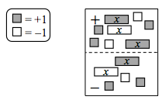
- CL 2-90 Examine the Expression Mat at right.
  - Write an expression for the tiles as they appear.

  - On the drawing, circle all of the zeros that you can find to simplify the expression.
  - Write the completely simplified expression.

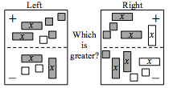
- CL 2-91. Write expressions for each side of the Expression Comparison Mat. Use “legal” moves to simplify and determine which is greater.

- CL 2-92. Define a variable and then write an equation for the following problem. Remember that you can use the 5-D Process to help you do this. Then solve your equation and state your answer in a sentence. Show your work in an organized way.
The number of students attending the fall play was 150 more than the number of adults attending. Student tickets cost $3, and adult tickets cost $5. A total of $4730 was collected. How many students attended the play?

- CL 2-93. Simplify each expression with or without algebra tiles. Record your steps.

  - 3 + 7x − (2 + 9x) b. 6 − (3x − 4) + 7x – 11 c. 3x² + 10 − y² + 4x − 8x² − 5y − 8 + y² + 3

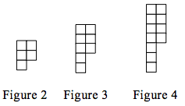
- CL 2-94. Copy the pattern at right onto graph paper. Draw Figures 1 and 5 on your paper.
  - How many tiles are in each figure?

  - How is the pattern changing?

  - How many tiles would Figure 6 have?

- CL 2-95. Evaluate 6x − (3y + 7) − xy when x = 5 and y = 3.

- CL 2-96. Molly bought 4.25 pounds of fish for $10.20.
  - What is the unit rate (cost per pound)?

  - What should six pounds of fish cost at the same rate?

  - Write and equation relating cost (c) with pounds (p).

