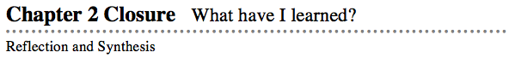
- The activities below offer you a chance to reflect about what you have learned during this chapter. As you work, look for concepts that you feel very comfortable with, ideas that you would like to learn more about, and topics you need more help with.

1. SUMMARIZING MY UNDERSTANDING
- This section gives you an opportunity to show what you know about the main math ideas in this chapter.
- Simplifying and Solving Equations
- Obtain the Chapter 2 Closure Resource Page, Simplifying/ Solving Graphic Organizer (GO), from your teacher.
- Your Task:
  - Imagine that you are the teacher for some students who have just finished this chapter. You need to make a test to determine how well they know how to use algebra tiles to represent an equation as well as how to simplify and solve for the variable.
  - With your team, first brainstorm all of the things that such students would need to know about using algebra tiles. This is the list of the concepts that you would assess with your test.

  - Then, as a team, create one equation that would allow you, as the teacher, to assess the students’ understanding of many of the concepts that you listed. Try to make your equation easy enough for the students to do, but challenging enough that you will be able to tell if they understand the list of concepts very well.

  - Use the Chapter 2 Closure Graphic Organizer to create an answer key for the problem that you created. Your key should help you assess the work that students turn in. Be sure to include each step as a tile drawing and as a symbolic equation. Also be sure to write an explanation of what the students would do at each step. If your equation takes more than four steps, then continue your work on another piece of paper or on an additional GO page.

  - Check your teammates’ answer keys for accuracy.

