Name:
Date:

Chapter 1 Review
Doing the problems in this section will help you to evaluate which types of problems you feel comfortable with and which ones you need more help with.
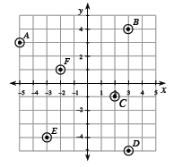
Solve each problem as completely as you can. The table at the end of this closure section provides answers to these problems. It also tells you where you can find additional help and where to find practice problems like them.
- CL 1-62. Write the coordinates of each point (A through F) circled on the graph below in (x, y) form.

- CL 1-63. Draw and label x- and y-axes on graph paper. Find and label the following points:
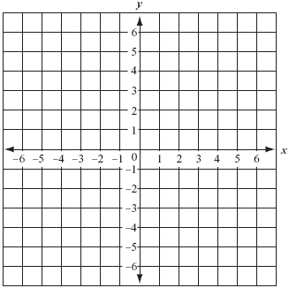
  - G(3, 2)
  - H(1, 4)
  - I(−2, −1)
  - J(4, −2)
  - K(−5, 1)

- CL 1-64. Define a variable and then write and solve an equation for the problem below. Use the 5-D Process, if needed. Show your work in an organized way.
  - Ralph and Alphonse are shooting marbles. Ralph has five more marbles than Alphonse, and they have a total of 73 marbles. How many marbles does each of them have?

CL 1-65. On graph paper, draw at least six different-sized rectangles that have an area of 12 square units. Then find the perimeter of each rectangle.

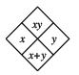
- CL 1-66. Copy and complete each of the Diamond Problems below. The pattern used in the Diamond Problems is shown at right.
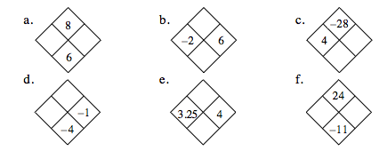
- CL 1-67. Draw the 1st and 5th figures on your paper.
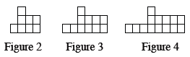
  - How many tiles are in each figure?

  - Describe how the pattern is changing.

  - How many tiles would the 6th figure have? The 10th figure?

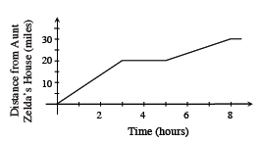
- CL 1-68. Zeke lives 30 miles from his aunt, Zelda, and is riding his bike home from her house. Interpret the graph to tell a story about what could have happened on his ride home.

- CL 1-69. For each of the problems above, do the following:
  - Draw a bar or number line that represents 0 to 10.
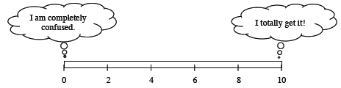
  - Color or shade in a portion of the bar that represents your level of understanding and comfort with completing that problem on your own.
- If any of your bars are less than a 5, choose one of those problems and complete one of the following tasks:
  - Write two questions that you would like to ask about that problem.

  - Brainstorm two things that you DO know about that type of problem.

- If all of your bars are a 5 or above, choose one of those problems and do one of these tasks:
  - Write two questions you might ask or hints you might give to a student who was stuck on the problem.

  - Make a new problem that is similar and more challenging than that problem and solve it.

