Name:
Date:
Unit 10 Closure
- CL 10-72. Find the surface area and volume of each solid below.

  - All angles are right angles.
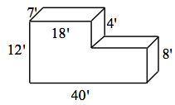
  - Right prism with base area = 48 cm²
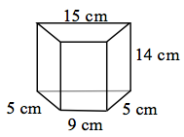

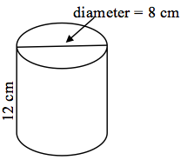
- CL 10-73. Find the surface area and volume of the cylinder at right. Show your work clearly.

- CL 10-74. Find the volume of a pyramid that has a square base with sides of eight inches and a height of 12 inches.

- CL 10-75. Ella’s cat has climbed up onto the roof of her house and cannot get down! The roof of the house is 24 feet above the ground. The fire department has set up a 28-foot ladder to climb to rescue the cat. The base of the ladder is resting on the ground, and the top of the ladder extends 2 feet beyond the edge of the roof. How far away from the base of the house is the base of the ladder? You may want to draw a diagram to help you solve the problem.

- CL 10-76. Simplify the product or quotient. Be sure your final answer is in scientific notation.
  - (3.25 × 10⁵)(4 × 10³)
  - 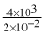

- CL 10-77. If a cube has a volume of 50 cm³, what is the length of a side?

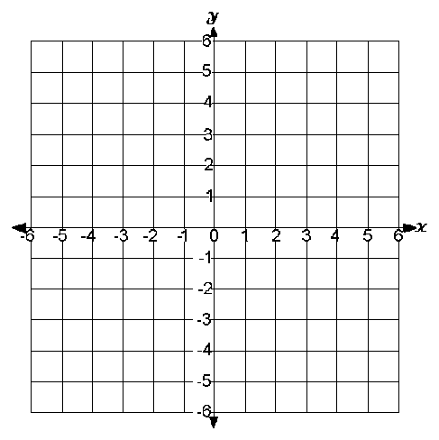
- CL 10-78. Given the equation of the line 6x − 2y = 10 , complete each of the following problems.
  - Solve the equation for y.

  - State the slope of the line.

  - Graph the line.

- CL 10-79. Two brothers, Martin and Horace, are in their backyard. Horace is taking down a wall on one side of the yard while Martin is building a wall on the other side. Martin starts from scratch and lays 2 bricks every minute. Meanwhile, Horace takes down 3 bricks each minute from his wall. It takes Horace 55 minutes to finish tearing down his wall.
  - How many bricks were originally in the wall that Horace started tearing down?

  - Represent this situation with an equation or system of equations. Be sure to define your variable(s).

  - When did the two walls have the same number of bricks?

