Name:
Date:
Lesson 7.3.3 Homework
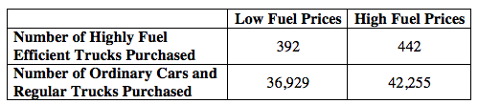
- 7-110. An unusually severe increase in gasoline prices may have motivated full-sized pickup truck buyers to purchase a highly fuel-efficient vehicle. Purchase behavior was collected in one area for one year and reported below.

  - Complete the row and column totals. What is the independent variable?

  - Create a relative frequency table. Is there an association between fuel prices and the number of highly fuel-efficient trucks purchased?

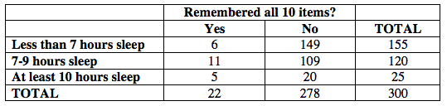
7-111. Researchers have determined that teenagers’ memories are negatively affected by getting less than 10 hours of sleep. Being good scientists, the math students at North Middle School were skeptical, so they did their own study. They asked 300 students to memorize 10 objects. The next day, each student was asked how much sleep he or she got and then was asked to list the ten items. The results are below.

Make a relative frequency table to determine if there is an association between hours of sleep and memory.

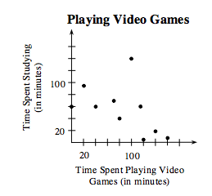
- 7-112. Ruthie did a survey among her classmates comparing the time spent playing video games to the time spent studying. The scatterplot of her data is shown at right.
  - What association can you make from her data?

  - Use an ordered pair (x, y) to identify any outliers.

7-113. Sao can text 1500 words per hour. He needs to text a message with 85 words. He only has 5 minutes between classes to complete the text. Can he do it in 5 minutes?

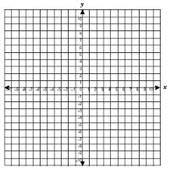
7-114. Where would the point (1, −8) be after each transformation described below?
  - Reflect (1, −8) across the x-axis, and then reflect that point across the y-axis.
  - Translate (1, −8) 5 units to the right and 3 units down.

7-115. This problem is a checkpoint for solving equations with fractions and decimals (Fraction Busters). It will be referred to as Checkpoint 7.
Solve each equation or system of equations.

  - $\frac{1}{5}$x +$\frac{1}{3}$x = 2

  - x + 0.15x = $2

  - $\left\{\begin{aligned}y=\frac{2}{3}x+8 \\ y=\frac{1}{2}x+10\end{aligned}\right.$

