Name:
Date:
Lesson 7.3.2 Homework
- 7-102. At a family reunion, each family member recorded his or her age and height.
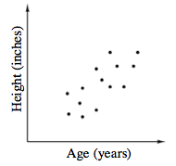
  - Fully describe the association.

  - Draw the trend line. Does your y-intercept make sense in this problem situation?

7-103. Marissa’s older sister was discussing purchasing a car with her summer job earnings. Marissa collected data from her friends at her job.
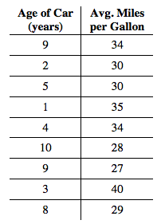
  - Marissa would like to know the typical age of her friends’ cars. What kind of graphical display should she use?

  - Marissa wants to convince her dad that newer cars are more fuel-efficient. What kind of graph(s) should Marissa make to convince her dad?
  - Make a scatterplot of the data.
  - Fully describe the association.

  - Draw a line of best fit on the data. Find the equation of the line of best fit.

  - Use the equation to predict what the correct mileage for a 7-year-old car should be.

  - Interpret the slope and y-intercept in this situation.

7-104. When Malcolm hops 10 times down the hallway, he travels 12 feet. How many times would he need to hop to travel to his class, 90 feet away?
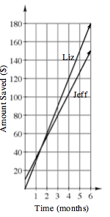

7-105. Jeffrey and Liz are each saving money for college. Their savings are shown in the graph at right.
  - Based on the graph, who is saving money fastest? Justify your answer.

  - What is the slope of each line? What does the slope tell you about this situation?

7-106. Simplify and solve the following equations.

  - 3x + 4.5 = 4.5x – 18

  - 6.25x + 7.5 − 2.5x = 3.75x − 8.75

