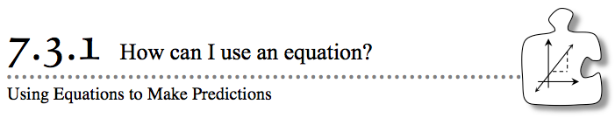
- Previously, you have learned to find and extend patterns in data and to make predictions using rules, equations, and graphs. Today you will apply these mathematical tools to a real situation in which your data does not make a perfect pattern.
- 7-87. AURÉLIE’S BIKE RIDE
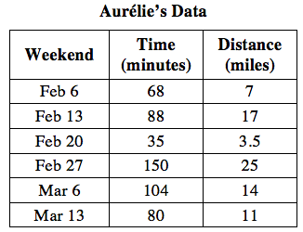
- To prepare for a 30-mile ride for charity, Aurélie has been biking every weekend. To predict how long the charity event will take her to complete, Aurélie has been keeping track of her time and distances. She tries to ride at a constant pace, but of course that is not easy to do.
  - Would a box plot, scatterplot, or histogram be most useful in helping Aurélie make a prediction?
  - Considering that Aurélie is trying to predict how long it will take to complete the ride, which is the independent variable and which is the dependent variable? Make a scatterplot.
  - Use a line of best fit to predict how long it will take Aurélie to complete the charity ride. Remember that the line does not need to intersect each of the points and that the line does not need to pass through the origin to model the data.
7-88. USING AN EQUATION TO MAKE PREDICTIONS
Sometimes it is more convenient and more accurate to use an equation to make a prediction rather than making a prediction by reading a graph.
  - Choose two points that lie on your line of best fit. These points can be given data points or lattice points on the coordinate grid. Use these two points to calculate the slope of your line of best fit. What does the slope mean in terms of Aurélie’s bike riding?

  - What is the y-intercept of your line of best fit? What does the y-intercept mean in terms of Aurélie’s training?

  - Write the equation of the line of best fit in y = mx + b form. Identify your variables.

  - Use your equation to predict how long the charity ride would take Aurélie to complete. How did your prediction compare to the prediction you made from the graph in part (c) of problem 7-87?

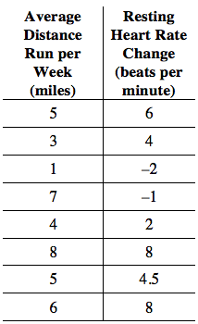
7-89. Westland Workers Union’s Health and Wellness Department started a voluntary lunchtime running club. Members kept track of how much they ran each week for exercise and how much their resting heart rate dropped over several weeks. Their data is in the table at right. Note that a negative heart rate change is actually a gain in heart rate.
  - Make a scatterplot of the data.
  - Describe the association.
  - Draw a line of best fit for the data. Find the equation of the line of best fit.
  - Use the equation to predict the heart rate change for an employee who ran 10 miles a week.
  - Interpret the slope and y-intercept in this situation.

