Name:
Date:
Lesson 7.3.1 Homework
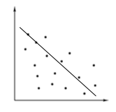
- 7-91. Anthony has added a line of best fit to the scatterplot at right. Do you agree with where he put the line? Explain your reasoning.

- 7-92. Graph y =$-\frac{1}{2}x$ + 6. Find its x- and y-intercepts.
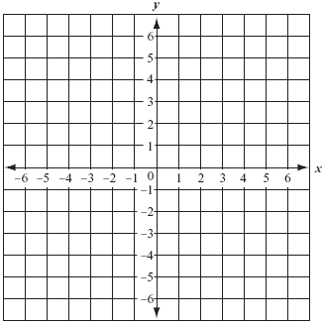

- 7-93. Graph a line that goes through the points (0, 3) and (2, −1). What is the slope of the line?

- 7-94. How many yearbooks should your school order? Your student government surveyed three homeroom classes, and 55 of 90 students said that they would definitely buy a yearbook. If your school has 2000 students, approximately how many books should be ordered? Show and organize your work.

- 7-95. Find the perimeter and area of each triangle below.
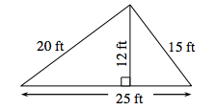
  - 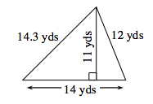
b.

7-96. Graph the lines y = −4x − 3 and y = −4x + 1 on graph paper.
  - Where do they intersect?

  - Solve this system using the Equal Values Method.

  - Explain how your graph and algebraic solution relate to each other.

