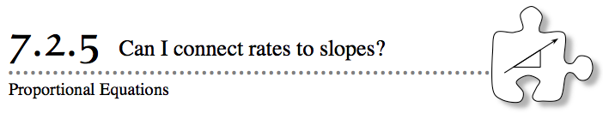
- In Chapter 1, you identified proportional relationships in both tables and graphs. Today you will look at the connection between slope and graphs of a proportional relationship.
- 7-77. POLITICAL POLL
- Mr. Mears was running for mayor of Atlanta. His campaign managers were eager to determine how many citizens of Atlanta would vote for him in the upcoming election. They decided to pay a respected, impartial statistical company to survey potential voters (a process called “polling”) to find out how many people would probably vote for Mr. Mears.
- One afternoon, pollsters called 100 random potential voters in Atlanta to ask them how they would vote in the election. During that survey, 68 people indicated that they would vote for Mr. Mears.
  - If the pollsters had instead called 50 randomly selected potential voters, predict how many of them would have said that they would vote for Mr. Mears. Is this relationship proportional? Why or why not?
  - Do you suppose that this relationship is proportional? Why or why not?
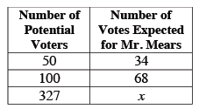
  - Carina’s neighborhood has 327 potential voters. If voting in her neighborhood is similar to that of the poll, how many neighbors will probably vote for Mr. Mears? Complete the table at right.
  - Make a graph of the data Carina has collected, and draw a line through the points. Should your line go through the origin? How do you know?
  - What is the equation of the line in y = mx + b form?
  - Use the equation to help Carina figure out how many people will probably vote for Mr. Mears if 350,125 people vote in the election. What do x and y represent in your equation?
  - What information would the unit rate give Carina? What is the unit rate? How does the unit rate compare to the slope?
7-78. In two minutes, Stacie can write her name 17 times.
  - Use a proportion (write equivalent ratios) to find how long it will take Stacie to write her name 85 times.

  - Make a graph of this situation. Which piece of information is on the dependent axis?

  - Another name for the slope in a proportional relationship is the constant of proportionality. Find the constant of proportionality and write an equation in y = mx + b form for Stacie’s situation. What do x and y represent in this situation?

  - Use the equation to find how many minutes it will take Stacie to write her name 85 times.

  - What is the advantage of the equation in part (d) compared to the proportion (equivalent ratios) in part (a)? What is the advantage of the proportion?

  - What is the unit rate at which Stacie writes her name?

7-79. Beth and her father have a large model railroad in their basement. Beth figured out that the equation y = $\frac{260}{3}$x relates the length of an item on her model railroad to the length of the real thing, where x is the size on the model and y is the real object’s size. Beth’s uncle has a different model railroad in his home. It has a different scale. He put together the following table for Beth.

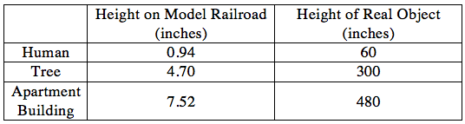
  - In decimal notation, what is the unit rate for Beth’s railroad? For her uncle’s railroad? Make sure you show units on your unit rate.
  - On which model would a horse be taller? Use the unit rates to justify your answer without making any calculations.

7-80. Eight of 29 students in your class want to attend the Winter Ball.
  - Find the constant of proportionality, and then write an equation in y = mx + b form. What do x and y represent?

  - If your class represents the entire school, how many of the 1490 students will probably attend the dance? Solve your equation from part (b).

