Name:
Date:
Lesson 7.2.5 Homework
- 7-81. Aja and Emilie were riding their skateboards. They knew that they could ride 3 miles in 20 minutes.
  - How far can the girls ride in 45 minutes?

  - If y represents the distance in miles and x represents the time in minutes, write an equation to represent the distance traveled for any time.

7-82. Joe is downloading songs from the Internet. He can download them at a rate of 8 songs every 10 minutes.
Jasmine, who is also downloading songs, can download at a rate of 12 songs every 15 minutes. Who is downloading songs faster?

7-83. Reflect quadrilateral ABCD across the line y = −2. Write the new coordinate points.
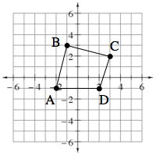

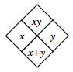
7-84. Copy and complete each of the Diamond Problems below. The pattern used in the Diamond Problems is shown at right.
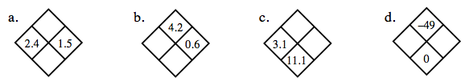

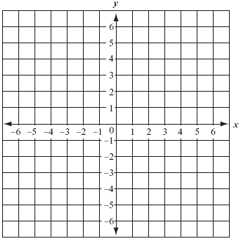
7-85. On graph paper, graph the line that goes through the points (–6, 3) and (–3, –1).
  - What is the slope of the line?

  - What is the y-intercept?

  - Find the equation of the line.

7-86. Mr. Crow, the head groundskeeper at High Tech Middle School, mows the lawn along the side of the gym. The lawn is rectangular, and the length is 5 feet more than twice the width. The perimeter of the lawn is 250 feet.
  - Define a variable and write an equation for this problem.

  - Solve the equation that you wrote in part (a) and find the dimensions of the lawn.

  - Use the dimensions you calculated in part (a) to find the area of the lawn.

