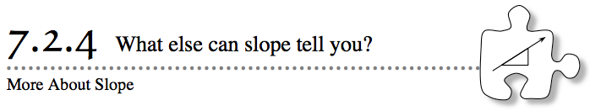
- In recent lessons, you have learned how to find the slope of a line. You have also learned how slope describes the rate of change and the steepness of a line on a graph. In this lesson, you will learn about other information that the slope of a line can tell you.
- 7-67. Which is steeper: a line with a slope of $\frac{2}{5}$ or a line with a slope of $\frac{5}{2}$? How do you know? Explain.
- 7-68. Compare the two lines in the graph at right.
  - How are the two lines the same? How are they different?

  - Each line on this graph describes how much money a person has in his or her wallet over time (in days). Explain what is happening to the amount of money each person has. Be specific.

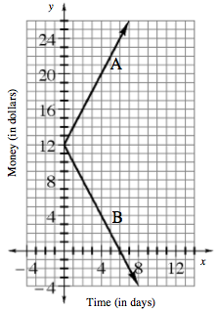
  - To describe how person A’s amount of money is changing, the unit rate (slope) represents the amount that is added each day. Since the value of money is increasing, the slope is positive. But what should you do when the value is decreasing? How should the decrease be reflected in the rate (slope)? Discuss this with your team.

  - Remember that the slope ratio compares how the change on the y-axis compares to the change on the x-axis. Lines that go up from left to right show positive rates of change, or positive slopes, while lines that go down from left to right show negative rates of change, or negative slopes.
Find the slope of each line in the graph.

7-69. WHAT IF IT DOES NOT GROW?
The graph at right shows three different lines.
  - Describe each line in words. Is it increasing or decreasing? Quickly or slowly?
  - Line B is different from the other two lines. As the x-value increases, what happens to y?

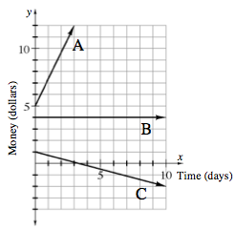
  - Slope is a comparison of $\frac{change in y}{change in x}$. Pick two points on line B. How can you use a number to represent the change in y between these two points? Use this number or the change in y to write a slope ratio for line B.

  - Recall that the units for the “change in y” are the same as the y-axis, and that the units for the “change in x” are the same as for the x-axis. What are the rates of growth for Line A and Line C? Be sure to include units.

  - Express the unit rates in part (d) as decimals with units.

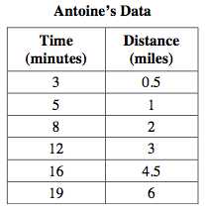
7-70. PERSONAL TRAINER
To prepare for biking long distances, Antoine has been trying to keep a steady pace as he bikes. However, since his hometown has many hills, he ends up biking faster and slower during different parts of his ride.
To track the distance and time when he trains for the triathlon, Antoine purchased a special watch that tells him how far he has traveled at specific time intervals. With the push of a button, he can set it to record data. Then, at the end of his workout, the watch gives him a list of the data.
  - On his first bike ride around town, he recorded several times and distances. These measurements are shown in the table at right. According to the table, does he appear to be traveling at a constant rate? Explain your reasoning.

  - Draw and label a graph that extends to 40 minutes on the x-axis and to at least 15 miles on the y-axis. Plot Antoine’s time and distance data on the graph. What type of graph is this?

  - Draw a trend line that best represents Antoine’s data. Then extend it to predict about how long it will take him to bike 10 miles (his normal long distance workout).

  - What is Antoine’s general rate during his bike ride? Find the slope (rate of change) of the trend line you drew in part (c) to determine his general rate.

