Name:
Date:
Lesson 7.2.4 Homework
- 7-71. For each pair of slope ratios, decide if they are equivalent (=), or if one slope is greater. If the slopes are not equal, use the greater than (>) or less than (<) symbol to show which is greater.

  - $\frac{6}{7}$, $\frac{5}{6}$

  - $\frac{3}{2}$, $\frac{15}{10}$

  - $\frac{12}{10}$,$\frac{7}{5}$

7-72. Describe the associations in the two graphs below. Remember to describe the form, direction, and outliers.
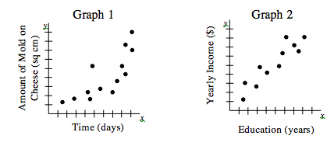

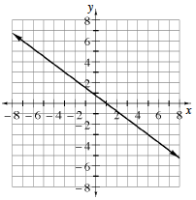
7-73. Ella and her study team are arguing about the slope of the line in the graph at right. They have come up with four different answers: $\frac{3}{4}$, $-\frac{4}{3}$, $-\frac{3}{4}$ and $\frac{4}{3}$. Which slope is correct? Justify your answer.

7-74. Solve each of the following equations.

  - $\frac{1}{6}x+\frac{2}{3}=\frac{1}{4}x-\frac{1}{3}$

  - 0.15(w + 2) = 0.3 + 0.2w

  - 3(2x − 7) = 5x + 17 + x

7-75. Salami and More Deli sells a 6-foot sandwich for parties. It weighs 8 pounds. Assume the weight per foot is constant.
  - How much does a sandwich 0 feet long weigh?

  - Draw a graph showing the weight of the sandwich (vertical axis) compared to the length of the sandwich (horizontal axis). Label the axes with appropriate units.

  - Use your graph to estimate the weight of a 1-foot sandwich.

  - Write a proportion to find the length of a 12-pound sandwich.

7-76. Find the area of the entire rectangle in each diagram below. Show all work.
a. 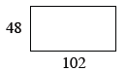 | b. 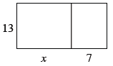
c. 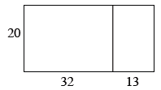 | d. 