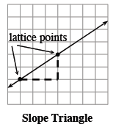
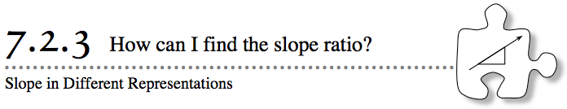
- In Lesson 7.2.2, you learned about how to use a number to describe the steepness of a line. Today, you will work with different representations of lines and look for how the slope can be found in each representation.
- 7-55. A planting manual printed the graphs below so that gardeners could predict the height of trees after planting. Jill wants to figure out the rate that each tree will grow.
- She remembers that slope is a ratio of the vertical change to the horizontal change between any two points on a line. The units for the vertical change are the same as the y-axis, and the units for the horizontal change are the same as the x-axis. Finding the slope for each graph will allow her to compare the change in height to the change in time.
  - On a Lesson 7.2.3 Resource Page draw and label a slope triangle on the line in graph (i). Then write the slope ratio. How fast does the tree in graph (i) grow?
  - Can you find the slope on graph (ii) just by looking at the line? Why or why not? When it is difficult to read the slope on a graph, look for points where the line appears to pass through lattice points (where the grid lines intersect). Then use those points to create a slope triangle and find the slope for graph (ii).
  - On the resource page, use lattice points to draw a slope triangle for each of the lines in graphs (iii) and (iv). Then label each slope triangle with its dimensions and calculate the slope ratio.
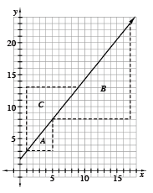
7-56. Three different students looked at the line graphed at right, and each drew a different slope triangle. Their slope triangles are labeled A, B, and C in the graph at right.
  - Find the length of the horizontal and vertical sides of each slope triangle A, B and C on the Lesson 7.2.3 Resource Page What is the relationship between triangles A, B, and C? Explain your answer. Using what you learned in Chapter 6 about the ratios of side lengths of similar figures may be helpful.

  - Find each slope using the slope triangles.
  - The numbers in the slope ratios found by the students are all different. Does this mean that the slope of the line changes depending on which points you pick? Discuss this with your team and be ready to share your reasoning with the rest of the class.
  - Another student said her slope triangle goes up 20 units for every 16 units to the right. Where could her slope triangle be? Draw a possible slope triangle for this student.
  - Simplify each of the four slope ratios and compare them. Describe what you find.
7-57. IS SEEING BELIEVING?
Did you know that a bank will pay you money (called interest) when you place your money in a savings account? The amount you receive is a portion of the amount you deposit. The interest rate often varies with each bank.
Thomas and Ryan have each invested the same amount of money in different bank accounts that earn simple interest. Simple interest means the same amount of interest is added for each time period. In this case, the interest is added each week. Thomas and Ryan decided to compare their rate of earnings by graphing how much interest each of them has earned over time. Their graphs are shown below.
  - When you look at the graphs, which investment seems to be growing fastest? Explain how you decided.
  - The tables for Thomas’ and Ryan’s accounts are shown at right. Which table reflects Thomas’ interest? Which one reflects Ryan’s interest? How do you know?
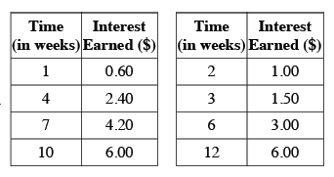
  - Use the tables to find the rate of interest earned (in dollars) to time (in weeks) for each of them. Whose money is growing faster?
  - Did your answers from parts (a) and (c) agree? If not, compare the tables and graphs with your team to find out why the line that is less steep actually represents the bank account that grows faster. Be ready to share your ideas about why the graphs look the way they do.
7-58. The students in a study team are now arguing about who has graphed the steepest line. Assume that they set up their axes with the same scale. Here is some information about their lines:
Lucy: slope = | Bree: slope =
Cliff: slope = | Geetha: slope =
Can you use the slopes of their lines to visualize how each of the lines would look on a graph? Discuss their lines with your team, and then settle their argument without graphing. Explain completely who has the steepest line and who has the least steep line.
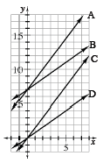
7-59. Which lines on the graph at right and on your resource page appear to have the same slope? Which line or lines are steepest? First, make a prediction. Then check your prediction by finding the slope of each line in the graph on the Lesson 7.2.3 Resource Page

