Name:
Date:
Lesson 7.2.3 Homework
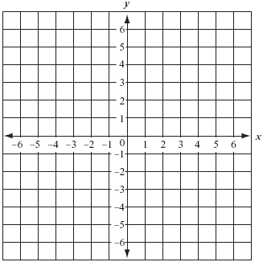
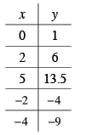
- 7-61. Graph the points in the table at right and draw a line. Then, find three different ratios to describe the slope of this line.

- 7-62. Find the slope of each line below.
a. 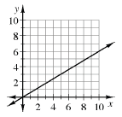 | b. 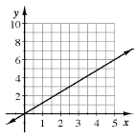 | c. 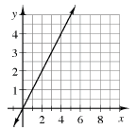

- 7-63. For each equation below, solve for x and check your answer.

  - 10(0.02x − 0.01) = 1

  - $\frac{1}{3}$x − 6 = 8

  - 0.9x − 2.1 + 0.9 = 0.2(5 − x)

7-64. Write and solve an equation for the situation below. Define any variables and write your solution as a sentence.
Jennifer has a total of four-and-a-half hours to spend on the beach swimming and playing volleyball. The time she spends playing volleyball will be twice the amount of time she spends swimming. How long will she do each activity?

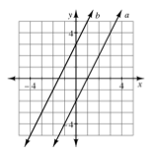
7-65. When Yoshi graphed the lines y = 2x + 3 and y = 2x − 2, she got the graph shown at right.
  - One of the lines at right matches the equation y = 2x + 3, and the other matches y = 2x − 2. Which line matches which equation?

  - Yoshi wants to add the line y = 2x + 1 to her graph. Predict where it would lie and sketch a graph to show its position. Justify your prediction.

  - Where would the line y = −2x + 1 lie? Again, justify your prediction and add the graph of this line to your graph.

7-66. Solve each of the following equations. Be sure to show your work and check your answers.

  - 2(3x − 4) = 22

  - 6(2x − 5) = −(x + 4)

  - 2 − (y + 2) = 3y

  - 3 + 4(x + 1) = 159

