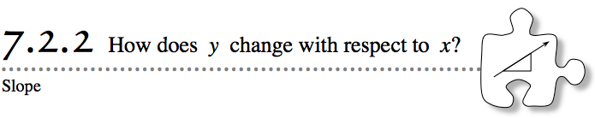
- Can you imagine swimming 1.5 km (just less than a mile), getting dressed as fast as you can, hopping on a bicycle to race 40 km (almost 25 miles), then getting off your bike to run 10 km (just over 6 miles)? Athletes who compete in Olympic distance triathlons do exactly that! In the 2008 Summer Olympic Games, Jan Frodeno of Germany won the gold medal by finishing the triathlon in 1 hour, 48 minutes and 53.28 seconds. Frodeno did not finish the swimming section in first place, though. In fact, he was not even one of the first ten people to finish that part of the race. While Frodeno may not have been the fastest swimmer, what mattered most was his overall rate.
- As you compare rates today, you will learn a new way to describe the growth rate of a line called slope.
- 7-43. BIKING THE TRIATHLON
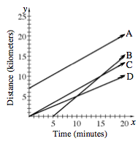
- The second part of the triathlon is a bicycle race. Since participants do not start the bicycle race until they complete the swimming portion, the bicyclists have varying starting times.
The graph at right shows information about four bicyclists during a 20-minute portion of a race.
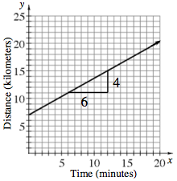
  - Based on the graph, list the bicyclists from slowest to fastest. How can you tell?
  - Lydia wants to describe each bicyclist’s rate in kilometers per minutes for an article in the school paper. To do this, she sketched triangles like the one for line A on the graph at right.
Where do the 4 and 6 come from on Racer A’s triangle? What do they represent?
  - These numbers can be written as a rate in kilometers per hour to describe the distance the bicyclist rides as time passes. The fraction $\frac{4}{6}$ represents how the graph of the line goes up 4 units for every 6 units that it moves to the right. The number $\frac{4}{6}$ is called the slope of the line.
On the Lesson 7.2.2 Resource Page, find the slope of each of the other three lines.
  - Did the slopes in part (c) confirm your ranking from slowest to fastest in part (a)? If not, review your slopes and your comparison of rates based on the graph to find any mistakes.
7-44. Look at your “Biking The Triathlon” Resource Page from problem 7-43. Slope can also be thought of as a unit rate.
  - Remember that a unit rate compares the change in one quantity to a one-unit change in another quantity. Find the unit rate for each of the triathlon bicyclists. Make sure you label the units.
  - Write each of the bicyclist’s rates as a decimal rounded to the nearest one-hundredth of a kilometer per minute. When you order the bicyclists’ rates, do you get the same results as in problem 7-35?
7-45. While comparing the rates from problem 7-43, a study team is struggling to decide how to tell which athlete is moving faster.
  - Leo thinks that because athlete A’s line is highest on the graph, he is traveling faster.
  - Kara disagrees. “He starts first, but racer B is moving faster."
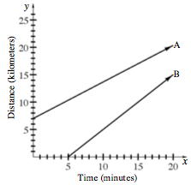
Which person do you agree with? Look at the graph of bicyclists A and B above and discuss this with your team. Be prepared to explain your reasoning to the class.

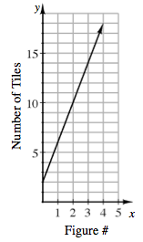
7-46. In Chapter 4 (problems 4-8 through 4-10), you looked at how tile patterns grow. You examined how the growth rate could be seen in the table, graph, and rule for the pattern. One of the patterns that you looked at and its graph are shown below.

  - What is the growth rate for this pattern? How can you tell?
  - What is the slope of the line on the graph? How does this value compare to the growth rate for the pattern?
7-47. Mr. Regnier’s class has been struck with hiccups! Three of the students track their number of hiccups over time. Assume each student hiccups at a constant rate.

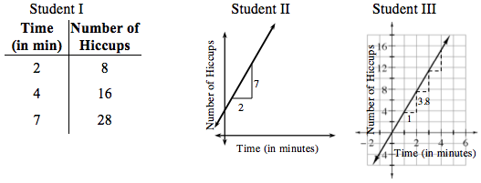
  - Which student has the most hiccups per minute? Justify your answer.
  - Find the slope that describes the rate of hiccups for each student. What does the slope tell you about each student?
  - If you graphed a line for the student who hiccups 4 times per minute, would the line be steeper, less steep, or the same steepness as the line in the graph for Student II? Explain your reasoning.

7-48. Additional Challenge: CHANGING LINES
Lupe is a manager of an assembly line at a manufacturing company that makes cars. The speed at which the cars are usually built is represented by the graph at right.
Lupe has decided to increase the number of cars built each day and has written directions for her employees. How would each of her directions below change the number of cars built each day? Explain how you know.
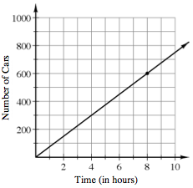
- Build 200 cars every 4 hours.

- Build 75 cars every hour.

- Build 500 cars every 5 hours.

- Decrease the time it takes to make each car.

