Name:
Date:
Lesson 7.2.2 Homework
- 7-49. Compare the graphs of lines A, B, and C at right.
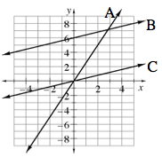
  - Which line has the greatest slope? Justify your answer.

  - What is the y-value of line A when x = 2?

  - Compare the slopes of lines B and C.

7-50. Lydia drew a graph of four athletes in the final part of the triathlon, the 10 km run. She found the slope of each runner’s line. Her results are listed below.

Runner A: slope = | Runner B: slope =
Runner C: slope = | Runner D: slope =
List the runners from slowest to fastest.

7-51. If a car is parked on the side of the road and not moving, what is its speed? What would it look like on a graph of time and distance?

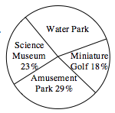
7-52. The class advisor was helping students plan an end-of-year trip. The students were surveyed about their choices. The results are shown in the circle graph at right.
  - What percent of the students chose the water park?

  - Which two results are very close?

  - Write a recommendation to the class advisor regarding what the next step would be.

- 7-53. Solve this problem by defining a variable, writing an equation, and solving it. Write your solution in a sentence.
The number of students attending the fall play was 150 fewer than three times the number of adults. Together, students and adults purchased 1778 tickets. How many students attended the fall play?

- 7-54. The figures below are similar. Use the information given about the lengths of the sides to solve for x and y.
