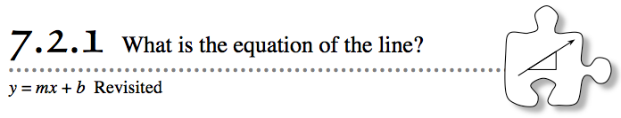
- Previously, you developed ways to find the growth of a line using its rule, table, and graph. You also learned how the y-intercept is present in each of the representations. In this lesson, you will enhance your study of lines and will develop ways to find the equation of a line using different pieces of information about the line, such as two points that are on it. Today’s lesson will help you review connections you made in previous chapters by challenging you to find equations for lines from multiple representations.
- 7-35. THE LINE FACTORY
- Congratulations! You have recently been hired to work at the city’s premiere Line Factory. People from all over the country order lines from your factory because of their superior quality and excellent price.
- Lately, however, the Line Factory is having a serious problem:Too many customers have placed orders and then have received lines different from the ones they wanted. The factory has hired your team to correct this problem.
- Your Task: Review the recent orders below and decide if there is anything wrong with each customer’s order. If the order is correct, then pass it on to your production department with a rule, a table, and a graph (on graph paper). If the order is incorrect, explain to the customer how you know the order is incorrect and suggest corrections.
  - Customer A wants a line that has y-intercept at (0, −3) and grows by 4. She ordered the line y = −3x + 4.
  - Customer B wants the line graphed at right. He ordered the line y = 3x + 2.

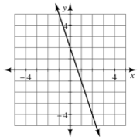
  - Customer C wants a line that passes through the points (2, −4) and (5, 2). She ordered the line y = 2x − 8.

  - Customer D wants the line that is represented by the table below.
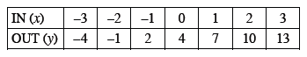
  - Customer E ordered the line 2x − y = 4 and wants the line to grow by 2 and pass through the point (5, 6).
  - Customer F wants a line that starts at (0, 1), grows first by 3, and then grows by 5.
7-36. For the customer order that your team is assigned, prepare a team poster with your analysis from problem 7-35. Every team poster should include:
  - The original customer order, complete with any given table, rule, graph, or statements.
  - An explanation of any errors your team found in the order. If your team did not find any errors, the poster should justify this fact as well.
  - Suggestions for how the customer can fix his or her order. You may want to suggest an equation that you suspect the customer wanted. If no mistake was made, then write a note to the company's production department with a rule, a table, and a graph for the order.

