Name:
Date:
Lesson 7.2.1 Homework
- 7-37. Would you expect a scatterplot comparing “speed of a car” and “time it takes to drive 10 miles” to show a positive association, a negative association, or no association? Explain your thinking.

- 7-38. Okie is a western lowland gorilla living at the Franklin Park Zoo near Boston, MA. He loves to finger paint! Many of his paintings have been sold because their colors are so interesting. One painting was sold for five times the amount of a second, and a third was sold for $1500. If the total sale was for $13,500, how much did the most expensive painting sell for?
Define a variable and then write and solve an equation to solve the problem. Remember to write your answer as a complete sentence.

- 7-39. Mt. Rose Middle School collected canned food to donate to a local charity. Each classroom kept track of how many cans it collected. The number of cans in each room were: 107, 55, 39, 79, 86, 62, 65, 70, 80, and 77. The principal displayed the data in the box plot below.
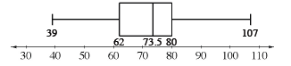
  - What is the range of the data? Are there any outliers?

  - The main office staff collected 55 cans, the counseling staff collected 74 cans, and the custodial staff collected 67 cans.
On graph paper, make a new box plot that includes this data. Clearly label the median and the upper and lower quartiles.

7-40. The trapezoids at right are similar shapes.
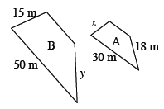
  - What is the scale factor between shape B and shape A?

  - Find the lengths of the missing sides.

7-41. MORE OR LESS
Judy has $20 and is saving at a rate of $6 per week. Ida has $172 and is spending at a rate of $4 per week. After how many weeks will each have the same amount of money?
  - Write an equation using x and y for Judy and Ida. What does x represent? What does y represent?

  - Solve this problem using any method you choose.

7-42. Simplify the following expressions.

