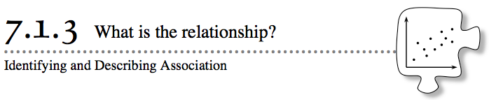
- When is it reasonable to make a prediction? For example, when you know the height of a tree, can you predict the size of its leaves? Or if you know the outdoor temperature for the day, can you predict the number of glasses of water you will drink during the day?
- In Lesson 7.1.2, you found that some data sets were related and others were not. In this lesson, you will look at different situations and decide if they show relationships that allow you to make predictions.
7-23. The students in Mr. Carle’s science class have been experimenting with different factors that they think may affect how tall a plant will grow. Each team planted seeds in several pots using different experimental conditions.
- With your team, read the questions that the students investigated. Write a team prediction (hypothesis) for the results for each experiment. Assume that all other variables are controlled (meaning that they will not affect the experimental outcome). Write your hypothesis so that it indicates a directional relationship between the independent and dependent variables.
  - Does the amount of fertilizer affect the plant height?
  - Does how deep the seed is planted in each pot affect the plant height?
  - Does the number of seeds in each pot affect plant height?
  - Does the size of the pot affect plant height?
  - Does the number of hours of sunlight per day affect the plant height?
7-24. After three weeks, the teams measured the heights of their plants and recorded the data. The Team 1 data table and the question Team 1 investigated are included below. On graph paper, make a scatterplot for the data gathered. Be sure that you:
  - Clearly label your axes.
  - Mark the scale at equal intervals.
  - Title your graph appropriately (such as with the experimental question).

- Team 1: Does the amount of fertilizer affect the plant height?
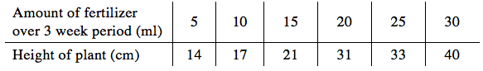

- 77-25. Your teacher will assign your team one of the remaining sets of data. Prepare a scatterplot poster for your assigned set of data. Be sure your graph has a title and that the axes are correctly labeled. Also make sure that the points on your graph will be easily seen from across the room.
- Team 2: Does the depth of seed in each pot affect the plant height?
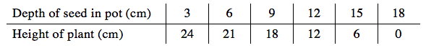
- Team 3: Does the number of seeds in each pot affect the plant height?
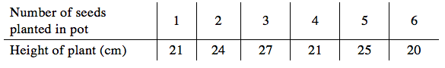
- Team 4: Does the size of the pot affect the plant height?
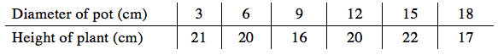
- Team 5: Does the number of hours of sunlight per day affect the plant height?
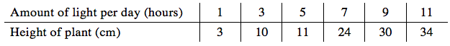

7-26. Examine your scatterplot for Team 1 from problem 7-24. Also look at the scatterplot posters created by your classmates for Teams 2 through 5. Then answer the following questions.
- a. For each of the graphs of data, does there appear to be a relationship? Describe the relationship by completing the appropriate sentence below.
As ____ gets larger, then ____ gets ____.
OR
There appears to be no relationship between ____ and ____.

- DIRECTION OF ASSOCIATION
In a scatterplot, if there appears to be no relationship between the variables, then the points in the scatterplot have no association. But if one variable generally increases as the other variable increases, there is said to be a positive association. If one variable generally decreases as the other variable increases, there is said to be a negative association. See some examples below.
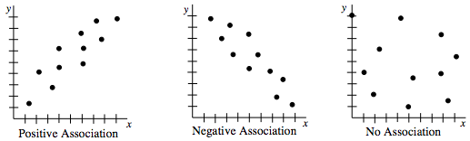
Review each of the graphs of the plant-experiment data and decide on the direction of the association. That is, decide if there is a positive association, a negative association, or no association.
- FORM OF ASSOCIATION
When there is a positive or negative association, the shape of the pattern is called the form of the association. Associations can have a linear form or a non-linear form, and the form can be made up of clusters of data. See some examples below.

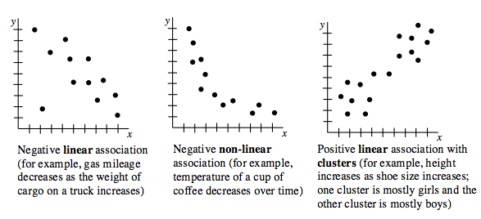
Review each of the graphs of the plant-experiment data that has an association, and decide on the form of the association. That is, decide if it is linear or non-linear, and whether it has clusters or no clusters.
- OUTLIERS
An outlier is a piece of data that does not seem to fit into the pattern. Do there appear to be any outliers in any of the example scatterplots above?
- Now go back and look at your team predictions (hypotheses) for each question in problem 7-23. Were your predictions accurate? Explain your reasoning.
- 7-27. When there is an association, predictions can be made. One way to help make predictions is to draw a line (or curve) of best fit for the data.
  - Find your graph of Team 1’s data from problem 7-24. Work with your team to draw a straight line that models (represents) the trend of the data on this graph. The line does not need to intersect each of the points, and the line does not need to pass through the origin.
  - Now use your line of best fit to predict the height of the plant when 12 milliliters of fertilizer are given to the plant over a 3-week period.
  - What is the y-intercept? Interpret the y-intercept in this situation.

