Name:
Date:
Lesson 7.1.3 Homework
- 7-29. For each scatterplot below, determine if there is an association between the points. Label each graph as showing a positive association, negative association, or no association. If there is an association, write a sentence describing it.
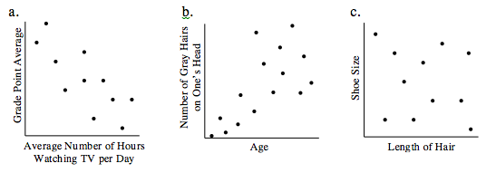

- 7-30. Make a graph of Team 2’s data from problem 7-25.
  - Draw a straight line that models the trend of the data on this graph. Remember, the line does not need to intersect each of the points.
  - Use your line of best fit to predict the height of the plant when the seed is planted 14 cm deep.
  - What is the y-intercept? Interpret the y-intercept in this situation.
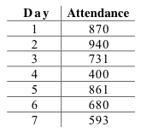
7-31. During a given week, the museum had attendance as shown in the table at right.
  - Numerically summarize the center and spread of attendance by finding the median and interquartile range (IQR).
  - The museum management needs to tell the staff members their work schedules a week in advance. The museum wants to have approximately one staff member for every 150 visitors. How many staff members should be scheduled to work each week? Explain your reasoning.
  - Why is a scatterplot not an appropriate display of this data?
7-32. Simplify each expression.

- $\frac{2}{3}(0.8)$

- $\frac{4}{3}∙\frac{3}{7}$

- $-\frac{5}{6}∙\frac{4}{7}$

- $-\frac{4}{5}∙\left(-1\frac{1}{3}\right)$

7-33. Solve each equation below for x. Check your solution.

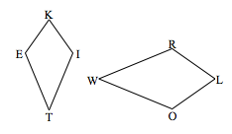
7-34. The figures at right are similar. Describe a sequence of transformations that will exhibit the similarity between them. Transform KITE to LOWR.

