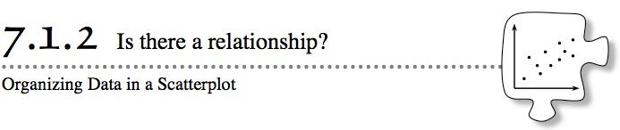
- In Lesson 7.1.1, you looked at single data sets, such as world population. Often, you need to compare two measurements to answer a question or to see a connection between two types of data. For example, comparing the odometer reading of a car to the price of a car can help determine if these factors are related. In this lesson, you will study scatterplots, a new tool for visually presenting data, as a way to relate two sets of measurements. You will be asked to analyze the data to see if you can make predictions or come to any conclusion about the relationships that you find.
- 7-13. HOW MUCH IS THAT CAR?
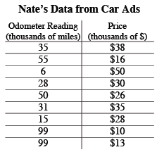
- Nate and Rick were discussing cars again. Nate claimed that cars with lower odometer readings were more expensive than cars with higher odometer readings. His evidence was that his car with 23,000 miles was worth more than Rick’s car with 31,000 miles. To investigate Nate’s claim, the boys collected data from several car advertisements and found the information in the table at right.
- Does the information in the table support Nate’s claim? That is, do you believe Nate’s claim that cars with a lower odometer reading cost more money?
- 7-14. Melissa looked at the data from problem 7-13 and said, “I need to be able to see the data as a picture. I cannot tell if there is a relationship from the lists of numbers.” She decided to use a box plot. Her box plots for odometer reading and price are shown below. Do these pictures help you decide if Nate is correct? Why or why not?
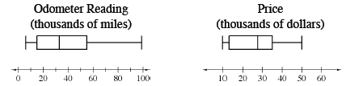

- 7-15. Melissa wondered if a coordinate graph could help determine if there was a relationship in Nate’s data from problem 7-13.
  - Follow the directions below to create a scatterplot of the data for Melissa.
    - Set up a graph showing Odometer Reading on the x-axis and Price on the y-axis.
    - Label equal intervals on each axis so that all of the data will fit on the graph.
    - Plot the data points from problem 7-13.
  - Describe the scatterplot you just created. What do you notice about how the points are placed on the graph? Do you see any patterns?
  - Place an additional point on your graph for Nate’s car that has an odometer reading of 23,000 miles. Explain your strategy for deciding where to put the point.
  - When a relationship exists, one way to help show a trend in the data is to place a line or curve that, in general, represents where the data falls. This line, sometimes called a line of best fit, does not need to touch any of the actual data points. Instead, it shows where the data generally falls. The line is a mathematical model of the data. Models of data help you describe the data more easily and help you make predictions for other cars with different mileages.
With your team, decide where a line of best fit could be placed that would best model the data points. Are there any limits to where your line makes sense?
  - Using the line of best fit, can you predict the price of a car with an odometer reading of 80,000 miles? If so, explain how the line of best fit helps. If not, explain why it is not helpful.
  - Based on the scatterplot, would you agree with Nate’s claim that cars with a higher odometer reading cost less? Use the scatterplot to justify your answer.

7-16. Sometimes what you know about relationships can help you predict what data will look like when it is graphed. For each situation below:
  - Look at the scatterplots and use your experience to decide which statement fits each scatterplot.
  - Decide if there is a relationship between the data. That is, as one quantity changes, does the other change in a predictable way?
  - If there is a relationship, describe it in a sentence.
  - If there is no relationship, explain why you think there is not one.
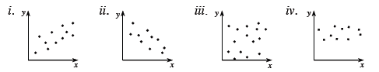
  - How fast a dog can run and the length of the dog's fur.
  - A person's age and their body temperature.
  - The child's age and the size of his or her feet.
  - Outdoor temperature and the percentage of people wearing long sleeve shirts.

