Name:
Date:
Lesson 7.1.2 Homework
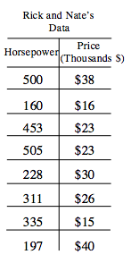
- 7-17. HOW MUCH IS THAT CAR?
Nate and Rick were still talking about cars. Nate claimed that cars with more horsepower were more expensive than cars with less horsepower. His reason was that his 300-horsepower sports car was worth more than Rick’s 120-horsepower small economy car. To investigate Nate’s claim, the boys looked up information about their friends’ cars. The table at right shows their results.
  - Does the information in the table support Nate’s claim that cars with more horsepower cost more? Is there a relationship between horsepower and the price of a car?

  - Set up a graph and plot the points from the table. Now do you believe Nate’s claim? Explain your reasoning.

7-18. Look at the scatterplots and use your experience to decide which statement fits each scatterplot. If there is a relationship, describe it in a sentence.
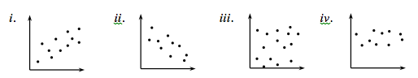
  - A city’s average daytime temperature in January and its latitude. Recall that the equator is at 0° latitude and the poles are at 90° latitude.

  - Weight of a car and its speed in a traffic jam on the freeway.

  - Number of pets a student has at home and his or her grades.

  - Cost of a person’s home and the value of his or her car.

7-19. Match the system of equations in the left column with its solution in the right column.
a. 6x − y = 4  3x + y = 5 | 1. (0, –4)
b. x = y + 4  2x + 3y = −12 | 2. (3, 7)
c. 5x − 2y = 1  y = 2x + 1 | 3. (1, 2)
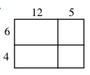
7-20. Use the rectangle at right to answer the following questions.
  - Find the area of the entire rectangle. Explain how you found your solution.

  - Calculate the perimeter of the figure.

7-21. Evaluate each expression below for a when a = , if possible.

  - 24a

  - 3a

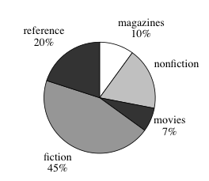
7-22. The school library has 6500 titles in its collection of books, magazines, and reference materials. The librarian is presenting information about the library to the parent association, and she made the graph at right.
  - According to the graph, what percent of the collection are nonfiction books?
  - Could the librarian have presented this information in a histogram? Why or why not?
  - How many of the books in the library are fiction?

