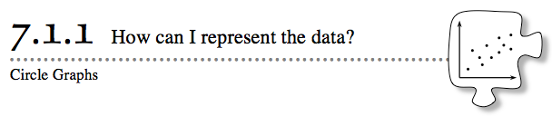
- Data can be found everywhere in the world. When scientists conduct experiments, they collect data. Advertising agencies collect data to learn which products consumers prefer. In previous courses, you developed histograms and box plots to represent the center and spread of data. How can you represent data that is non-numerical or that cannot be represented on a number line? Today you will look at a data display that is used for data that comes in categories or groups. As you work, keep these questions in mind:
- What portion is represented?
- Should I use a fraction or a percent?
- Am I measuring in percents or degrees?
- 7-1. HUMAN CIRCLE GRAPH
- Get a shape card from your teacher. Look at your shape and decide if your shape is a parallelogram, another form of a quadrilateral, a triangle, or some other shape. Follow your teacher’s directions to create a linear model and circle graph. Then answer the questions below.
  - Your class built a circle graph with your bodies. How can this model be drawn on paper? Work with your team to sketch a picture of your class circle graph showing the portion of your class that held parallelograms, other quadrilaterals, triangles, and other polygons. Be sure to label each section with the category of shape it represents and with an estimated percentage or angle measure.
  - Approximately what portion of the class held triangles? Write your answer as a percent. Then estimate the measure of the central angle on the graph for that portion. A central angle is an angle with its vertex at the center of a circle. Its sides are formed by two radii, and its measure is a portion of 360º.
  - Was there a section of the circle that had a central angle of approximately 90º? If so, what type of figure is represented in that section?

7-2. Nate and Rick are interested in buying a car. According to an ad in the paper, they found that there were 12 cars, 9 pickup trucks, 6 SUVs, and 3 minivans for sale in their price range.
  - How many vehicles were in Nate and Rick’s price range?
  - What portion of the total does each type of vehicle represent?
  - On the Lesson 7.1.1B Resource Page, create a circle graph of the vehicles in Nate and Rick’s price range. Label each section of the graph with the type of vehicle along with the fraction or percent of the circle it represents.
  - Calculate the central angle created by each section in the circle graph.
  - Is there another way to represent this data? Is a box plot, stem-and-leaf plot, histogram, or bar graph an appropriate way to display this data? Why or why not?
7-3. Circle graphs can be used to compare data at different points in time. Use the questions that follow to analyze the two circle graphs below.
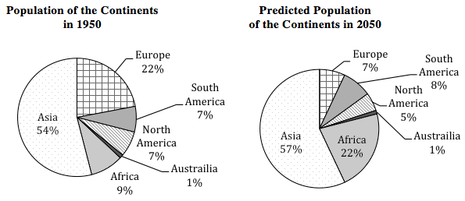
- According to the circle graphs, which continent had the largest population in 1950? Which has the largest predicted population in 2050? Do they represent the same percent of the world’s population in both graphs?
- Which continent is predicted to have its percent of world population increase the most between 1950 and 2050? By what percent is it expected to increase?
- Which continent is expected to have its portion of the total population shrink the most between 1950 and 2050? By how much will its percentage of world population change?
- Is it reasonable to say that continents with a small percentage of the world population in 1950 will have a small percentage of the world populatation in 2050? What evidence from the graphs can you provide to justify your answer?
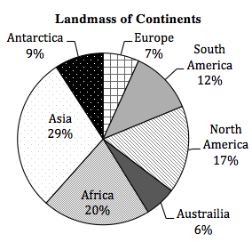
7-4. The world’s landmasses are divided into seven continents. The largest continent in terms of landmass is Asia, representing almost 30% of the earth’s land area. In contrast, the smallest continent is Australia, at about 6% of the earth’s land area. Use the circle graph at right to help you make the following comparisons.
  - Which continents are approximately the same size?
  - Which continent is about one-half the size of Asia?
  - Which continents together make up about half of the world’s land mass?

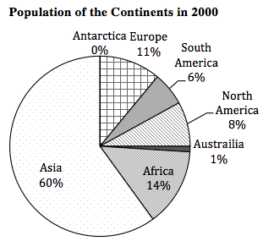
7-5. The population of the world’s people is not evenly divided over the earth’s surface. In 2009, only 0.0002% of people in the world lived in Antarctica, while 60% of people lived in Asia
  - Where is the portion representing Antarctica's population? Explain.
  - What similarities and differences do you notice about the landmass and population circle graphs in problem 7-4 and this problem?
  - Is it reasonable to say that larger continents have larger populations? Why or why not?

7-6. Additional Challenge: Take another look at the population graphs from problems 7-3 and 7-5, shown below.
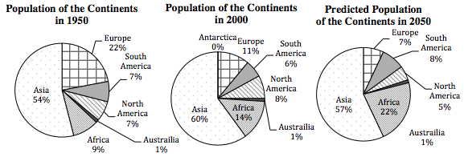

  - Note that Asia’s population percentage goes from 54% to 60% to 57%. However, the population of Asia is not expected to shrink between 2000 and 2050. How could this be true?
  - What kind of graph could be used so that misunderstandings like the one in part (a) would not occur?

