Name:
Date:
Lesson 7.1.1 Homework
- 7-7. Answer the following questions about the graph at right.
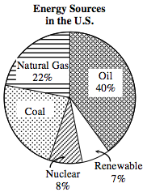
  - According to the graph, what percent of the energy in the United States comes from coal?

  - Which two sources of energy equal about one-third of the total energy for the United States?

  - What combination of energy sources provides about half of the total energy for the United States?

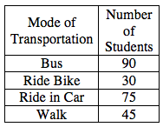
7-8. A group of classmates surveyed how other students travel to school. The results of the survey are shown in the table at right. Make a circle graph showing the results of the survey using percents.

7-9. Solve each equation below for the indicated variable.

  - 4x − 2 + y = 6 − 2x for y

  - 4x − 2 + y = 6 − 2x for x

  - 3(6 − x) + 2x = 15 for x

7-10. Find the solution for each system of equations below, if a solution exists. If there is not a single solution, explain why not. Be sure to check your solution, if possible.

- x + 4y = 2
x + 4y = 10

- 2x + 4y = −10
x + 2y = −5

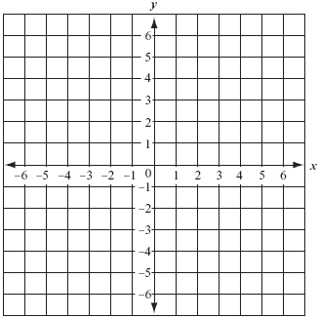
- 7-11. Graph the following points on a coordinate grid: A(−3, −3), B(3, 0), C(3, 6), D(−3, 6). Connect the points as you plot them. Then connect point A to point D.
  - Describe the shape you have created.

  - Identify the angles at points C and D.

  - Record the coordinates of the new points if you were to translate the original points three units left and five units up.

7-12. Use proportions to solve each of the problems below.
  - At the zoo, three adult lions together eat 250 pounds of food a day. If two more adult lions joined the group and ate food at the same rate as the original three, how much food would the zoo need to provide all five lions each day?

  - Byron can read 45 pages in an hour. At that rate, how long would it take him to read the new 700-page Terry Cotter book?

  - What is the unit rate of pounds of food per lion in part (a)?

