Name:
Date:
Lesson 6.2.6 Homework
- 6-103. For each expression below:
  - Sketch and label a pair of similar shapes (like those at right or in problem 6-92) that would result in each calculation.
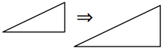
  - Rewrite the expression so that the operation is multiplication.
  - Calculate the value of the expression.

  - 6 ÷ $\frac{1}{2}$
  - 4 ÷ $\frac{2}{3}$

- 6-104. Sketch the triangle below. Then redraw it with sides that are as long as the sides of the original
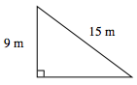
  - Calculate the perimeters of both triangles.

  - Calculate the areas of both triangles.

  - What is the relationship between the perimeters of the triangles?

6-105. Lucy and Marissa each designed a box plot to represent this data set:
16 18 19 19 25 26 27 32 35
Their plots are shown below. Which plot is scaled correctly and why? Explain the mistakes in the incorrect plot.

  - 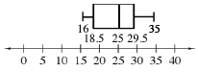
  - 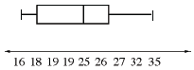

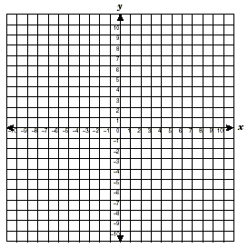
6-106. Draw a coordinate graph, and then plot and connect the following points: A(−3, 1), B(−1, 3), C(4, 2), D(2, 0).
  - What is the shape you created?

  - Reflect the shape across the x-axis. List the coordinates of the new points.

  - Multiply each coordinate of the original shape by 3. Graph the dilated shape. What are the new coordinates of the points?

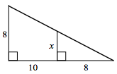
6-107. Examine the diagram at right. The smaller triangle is similar to the larger triangle. Write and solve a proportion to find x. It may be helpful to draw the two triangles separately.

6-108. SEQUENCES OF TRANSFORMATIONS
  - A figure is rotated and reflected. What can you say about the new figure in relation to the original figure?

  - A figure is translated, reflected, and then dilated. What can you say about the new figure in relation to the original figure?

6-109. This problem is a checkpoint for multiple representations of linear equations. It will be referred to as Checkpoint 6.
For each situation given below, complete the Representations of Patterns Web by finding the missing x → y table, graph, and/or rule. Since there are many possible patterns, it is not necessary to create one.

  - 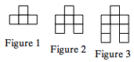

  - y = −3x + 7

  - 