Name:
Date:
Lesson 6.2.5 Homework
6-92. Sketch the two similar triangles below on your own paper. Find the scale factor and the missing side lengths.
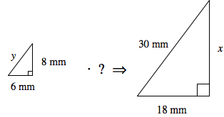
6-93. Alex and Maria were trying to find the side labeled x in problem 6-92. Their work is shown below.
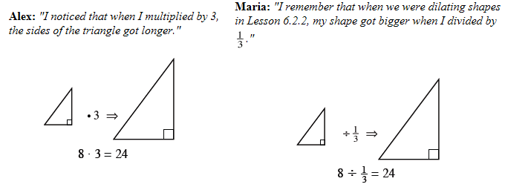
- Look at each student's work. Why do both multiplying by 3 and dividing by make the triangles larger?

- Use Alex and Maria’s strategy to write two expressions to find the value of y in problem 6-92.

6-94. Consider these two equations: a. Graph both equations on the same set of axes
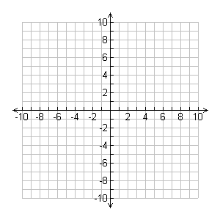
y = 3x – 2 y = 4 + 3x
b. Solve this system using the Equal Values Method.

- Explain how the answer to part (b) agrees with the
graph you made in part (a).

6-95. Hollyhocks are tall, slender, flowering plants that grow in many areas of the U.S. Here are the heights (in inches) of hollyhocks that are growing in a park: 10, 39, 43, 45, 46, 47, 48, 48, 49, 50, and 52.

- Find the median.

- Find the quartiles.

- Make a box plot of the data.

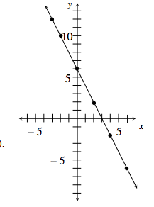
6-96. Use the graph at right to add points to the table below
- Write the rule in words.

- Explain how to use the table to predict the value of y when x is −8.

6-97. Use these following directions to create a mystery letter. On a piece of graph paper, draw a four-quadrant graph. Scale each axis from 6 to –6. Plot these points and connect them in order to create a rectangle: (2, 1), (2, 4), (3, 4), (3, 1). Be sure to connect the last point to the first point. Then follow the directions in parts (a) through (c) below.
- Rotate the rectangle 90° clockwise () about the point (2,1) and draw the rotated rectangle.
- Reflect the new rectangle over the line y = 2 and draw the reflected rectangle.
- Name the letter of the alphabet that your graph resembles.

