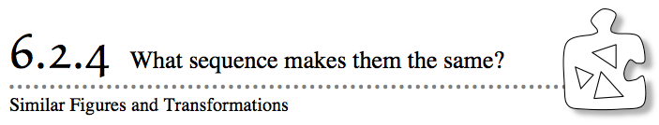
- So far in this chapter you have investigated transformations and similar figures. Recall that reflections, rotations, and translations are all special cases of transformations that are called rigid transformations. Today you will investigate how to use transformations to show that two figures are similar.
- 6-76. Use the graph at right.
  - Do you think the figures are similar? Why or why not?
  - Describe a sequence of transformations (reflections, rotations, translations, and dilations) to change Figure A to Figure B.
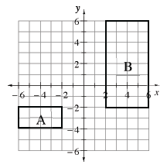
  - How does your sequence of transformations prove that the figures are similar?
6-77. Figures that are congruent are the same shape and the same size. You can also say they have a scale factor of 1. Which transformation(s) can you use to show that two figures are congruent? Which transformation(s) will cause figures that are not congruent, but similar?

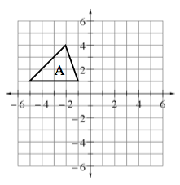
6-78. Angelina and Vee have each made a challenge for you. Begin with Figure A at right, and then follow the steps of their transformations to find the coordinates of the new figure, Figure B. Record your work on graph paper.
  - Angelina’s steps:
    - Reflect the triangle across the x-axis.
    - Rotate the triangle about the origin counter-clockwise () 90º.
    - Dilate the figure by a scale factor of $\frac{1}{2}$ (multiply the coordinate of each point by $\frac{1}{2}$).
Vee’s steps:
    - Translate the triangle 4 units right and 3 units down.
    - Rotate the triangle clockwise () 180º about its top vertex (point).
    - Reflect the triangle across the line x = 3.
Were your resulting figures congruent, similar, or neither? Explain.

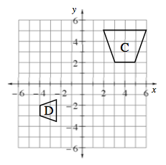
6-79. With your team, find a sequence of transformations that will transform Figure C to become Figure D.

