Name:
Date:
Lesson 6.2.4 Homework
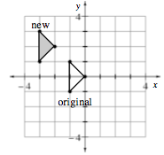
- 6-80. Use the graph at right.
  - Write directions for translating the original triangle to make the new triangle.

  - What are the coordinates of the vertices (corners) of the new shape?

  - On the graph, reflect the original triangle over the y-axis. What are the coordinates of the new triangle?

6-81. Hannah thinks the solution to the system below is (–4, –6). Wirt thinks the solution is (20, 10).
2x − 3y = 10
6y = 4x − 20
  - Is Hannah correct?

  - Is Wirt correct?

  - What do the answers to (a) and (b) tell you about the lines in the problem?
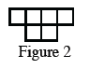
6-82. Figure 2 of a tile pattern is shown at right. If the pattern grows linearly and if Figure 6 has 18 tiles, then find a rule for the pattern.

6-83. Simplify the following expressions for x, if possible. Check your solutions.

  - −(2 − 3x) + x = 9 – x

  - 5 − 2(x + 6) = 14

  - $\frac{1}{2}$x − 4 = −3 −$\frac{1}{3}$x

6-84. Kevin found the box plot below in the school newspaper.
- 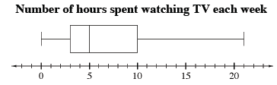
  - Based on the plot, what percent of students watch more than 10 hours of television each week?

  - Based on the plot, what percent of students watch less than 5 hours of television each week?

  - Can Kevin use the box plot to find the mean (average) number of hours of television students watch each week? If so, what is it? Explain your reasoning.

6-85. Solve each equation. Show all work.

  - 0.85x = 200
  - $\frac{7}{6}$x =140

