Name:
Date:
Lesson 6.2.3 Homework
- 6-70. Which of the shapes at right appear to be similar? Explain how you know.
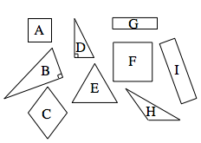

- 6-71. A local deli sells 6-inch sub sandwiches for $2.95. Now the deli has decided to sell a “family sub” that is 50 inches long. If they want to make the larger sub price comparable to the price of the smaller sub, how much should it charge? Show all work.

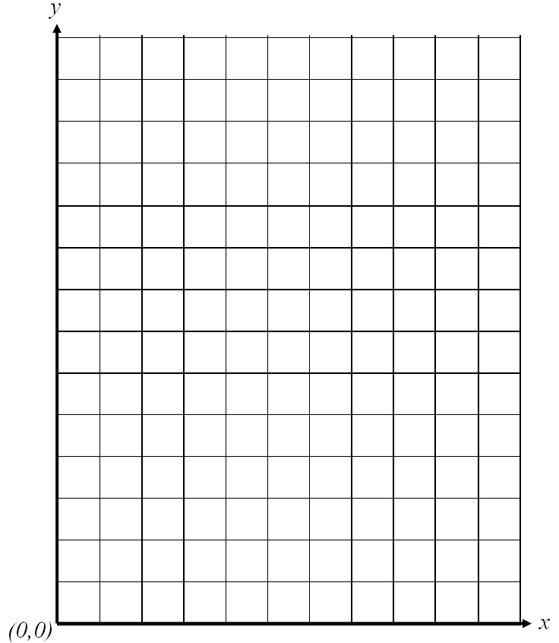
- 6-72. Represent the tile pattern below with a table, a rule, and a graph.
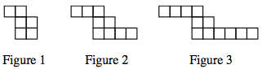

- 6-73. How many solutions does each equation below have? How can you tell?

  - 4x −1 + 5 = 4x + 3

  - 6t − 3 = 3t + 6

  - 6(2m − 3) − 3m = 2m − 18 + m

  - 10 + 3y − 2 = 4y − y + 8

6-74. Simplify each expression below.

  - $-2\frac{3}{10}-1\frac{2}{5}$

  - 3 ÷ $-\frac{5}{4}$

  - $\frac{3}{4}+5\frac{7}{8}$

  - $5\frac{1}{6}-\left(-\frac{7}{9}\right)$

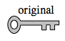
6-75. Look carefully at the key at right. Which of the keys below could you create by spinning (rotating) the original key? Which keys could you create by flipping (reflecting) the original key?
