Corresponding Parts of Similar Shapes
Two figures are similar if they have the same shape but not necessarily the same size. For example, all semi-circles are similar, as are all squares, no matter how they are oriented. Dilations create similar figures. | 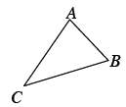
To check whether figures are similar, you need to decide which parts of one figure correspond (match up) to which parts of the other. For example, in the triangles at right, triangle DEF is a dilation of triangle ABC. Side AB is dilated to get side DE, side AC is dilated to get side DF, and side BC is dilated to get side EF. Side AB corresponds to side DE, that is, they are corresponding sides. Notice that vertex A corresponds to vertex D, C to F, and B to E. | 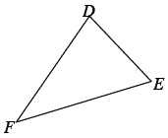
Not all correspondences are so easily seen. Sometimes you have to rotate or reflect the shapes mentally so that you can tell which parts are the corresponding sides, angles, or vertices. For example, the two triangles at right are similar, with R corresponding to X,S to Y, and T to Z. You can get triangle XYZ from triangle RST by a dilation of $\frac{1}{2}$ followed by a 90° counter-clockwise () turn. | 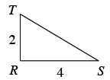
Shapes that are similar and have the same size are called congruent. Congruent shapes have corresponding sides of equal length and corresponding angles of equal measure. Rigid transformations (reflections, rotations, and translations), along with dilations with a multiplier of 1 or –1, create congruent shapes. | 