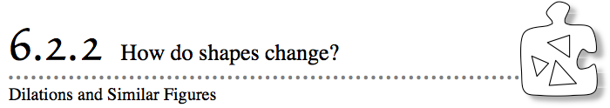
- In Lesson 6.2.1, you looked at dilations and multiplied each of the coordinates of a shape to change its size. Now you will explore how to undo dilations.
- Charlie multiplied each coordinate of the vertices of a shape by 4 to create the dilated shape at right.
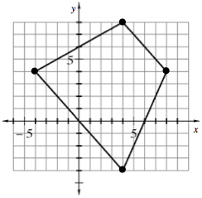
  - If Charlie multiplied to find this shape, what operation would undo his dilation? Why?
  - On a Lesson 6.2.2A Resource Page, undo the dilation on the graph at right. Label the vertices of Charlie’s original shape. How does the shape compare to the dilated shape?
6-53. Alana was also working with dilations. She wondered, "What would happen if I multiplied each coordinate of a shape by $\frac{1}{3}$?" On the Lesson 6.2.2A Resource Page, graph and connect the points below to form her dilated shape. Be sure to connect them in the order given.
  - (–1, –1) (–1, 1) (1, 2) (2, –1)Alana graphed this shape by multiplying each of her original coordinates by $\frac{1}{3}$. What do you think Alana's shape looked like before the dilation? Make a prediction.
  - On the same graph, undo the dilation to show Alana’s original shape. List the coordinates of the vertices of Alana’s original shape.
  - What did you do to each coordinate to undo the dilation? How did the shape change?
  - Why do you think the shape changed in this way?
6-54. With your team, look carefully at Alana’s dilated and original shapes in problem 6-53 and describe how the two shapes are related. Use the questions below to help you.
  - How are the sides of the small and large shape related?
  - How many of the small sides does it take to measure the corresponding (matching) side of the large shape? Is this true for all of the sides?
  - Compare the four angles of the smaller shape to those of the larger shape. What can you say for sure about one matching pair of these angles? What appears to be true about the other three pairs?
6-55. CHANGING SHAPE
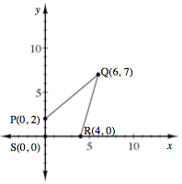
When you multiplied each coordinate of a shape by the same constant, you saw that sometimes the shape became smaller and sometimes it became larger. In this chapter, you moved shapes on a graph without changing their size or shape by rotating, reflecting, and translating them. In what other ways can you change a shape?
Your task: Work with your team to make predictions about what you could do to the coordinates of the shape above to make it look stretched or squished, and what actions will keep the shape the same. Make predictions for the situations presented below. You will test these predictions in problem 6-56.
6-56. Test the predictions your team made in problem 6-55. On the Lesson 6.2.2B Resource Page, graph each of the shapes described below.
  - Dilate each coordinate of shape PQRS by multiplying each x-coordinate and each y-coordinate by 4. Graph the dilated shape on the same graph using a color other than black.
  - Go back to the original shape, and this time multiply only the x-coordinates by 3. Leave the y-coordinates the same. Find, graph, and connect the new coordinates. What happened to the shape in part (b)? Why did this happen?
  - What happened to the shape in part (b)? Why did this happen?
  - Look at the predictions your team made in problem 6-55. Do you still agree with your predictions? Revise your predictions if necessary, based on your work so far. What do you think will happen if you multiply only the y-coordinates of the vertices by a number? Be ready to explain your reasoning.
6-57. Similar figures are figures that have the same shape, but not necessarily the same size. One characteristic of similar shapes is that the sides of one shape are each the same number of times bigger than the corresponding sides of the smaller shape.
Which pairs of shapes that you have worked with in this lesson are similar and which are not? Justify your answer using specific examples.

