Name:
Date:
Lesson 6.2.2 (Part 2) Homework
6-61. Normally, the longer you work for a company, the higher your salary per hour. Hector surveyed the people at his company and placed his data in the table below
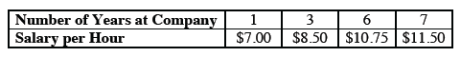
  - Use Hector’s data to estimate how much he makes, assuming he has worked at the company for 12 years.

  - Hector is hiring a new employee who will work 20 hours a week. How much should the new employee earn for the first week?

6-62. Mr. Greer solved the equation as shown below. However, when he checked his solution, it did not make the original equation true. Find his error and then find the correct solution.
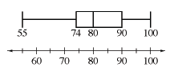
6-63. The box plot below shows the different grades (in percents) that students in
Ms. Sanchez’s class earned on a recent test.
  - What was the median score on the test? What were the highest and lowest scores?

  - Did most students earn a particular score? How do you know?

  - If Ms. Sanchez has 32 students in her class, about how many students earned a grade of 80% or higher? About how many earned more than 90%? Explain how you know.

  - Can you tell if the scores between 80% and 90% were closer to 80% or closer to 90%? Explain.

