Name:
Date:
Lesson 6.2.2 (Part 1) Homework
- 6-58. Using the graph below multiply the y-coordinate of each point by 4. Then graph the new shape. Make sure you connect your points. List the points for the new shape. Are the two figures similar? Why or why not?

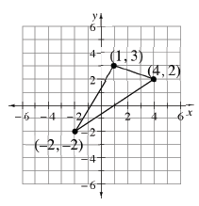

- 6-59. Lashayia is famous for her delicious brownies, which she sells at football games. The graph at right shows the relationship between the number of brownies she sells and the amount of money she earns.
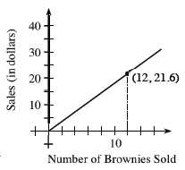
  - How much should she charge for 10 brownies? Be sure to demonstrate your reasoning.

  - During the last football game, Lashayia made $34.20. How many brownies did she sell? Show your work.

6-60. Figure 3 of a tile pattern has 11 tiles, while Figure 4 has 13 tiles. The pattern grows at a constant rate.
  - Write an equation to represent this situation.

  - Which figure number will contain 1015 tiles?

