Name:
Date:
Lesson 6.2.1 Homework
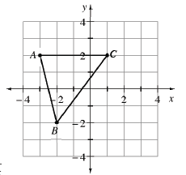
- 6-46. Louis is dilating triangle ABC at right. He multiplied each x-coordinate and y-coordinate of triangle ABC by –2.
  - What are the new coordinates of the points?

  - Graph Louis' new triangle.

  - Describe how triangle ABC changed.

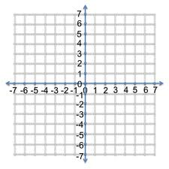
6-47. On the same set of axes, graph the two rules shown below. Then find the point(s) of intersection, if one (or more) exists.
y = −x + 2
y = 3x + 6

6-48. Evaluate the expression 6x² − 3x + 1 for x = −2.

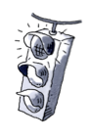
6-49. When Ms. Shreve solved an equation in class, she checked her solution and found that it did not make the equation true! Examine her work below and find her mistake. Then find the correct solution.
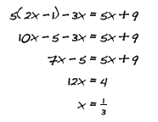

6-50. Determine if the statement below is true or false. Justify your conclusion.
2(3 + 5x) = 6 + 5x

6-51. Complete the missing entries in the table below. Then write the rule.
