Name:
Date:
Lesson 6.1.4 Homework
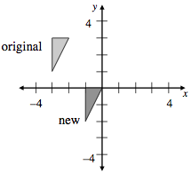
- 6-36. Use the graph at the right:
  - Write directions to translate the original triangle to make the new triangle.

  - What are the coordinates of the vertices (corners) of the new shape?

  - On your graph, reflect the original triangle across the y-axis. What are the coordinates of the new triangle?
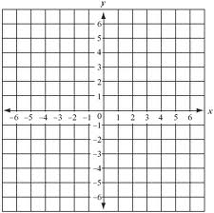
6-37. Make a table and graph for the rule y = −3x + 1.

6-38. Solve the system of equations below using the Equal Values Method.
a = 12b + 3
a = −2b – 4

6-39. Ms. Cai's class is studying a tile pattern. The rule for the tile pattern is y = 10x − 18. Kalil thinks that Figure 12 of this pattern will have 108 tiles. Is he correct? Justify your answer.

6-40. Angel is picking mountain blueberries for a delicious pie. She can pick $\frac{1}{6}$ cup of blueberries in 2 minutes. If she needs $2\frac{1}{2}$ cups of blueberries for the pie, how long will it take her to pick the berries?

6-41. Juan thinks that the graph of 6y + 12x = 4 is a line.
  - Solve Juan's equation for y.

  - Is this equation linear? That is, is its graph a line? Explain how you know.

  - What are the growth factor and y-intercept of this graph?

