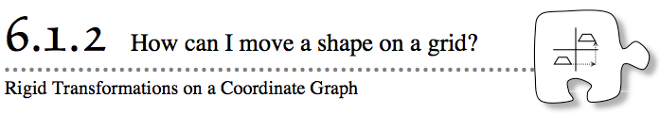

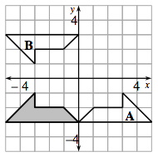
- Have you ever had trouble giving directions? Sometimes describing where something is or how it has moved is difficult. For this reason, people often use coordinate graphs like the one shown at right. Coordinate graphs help you describe directions with words like “left” and “down.” They can also help you measure distances.
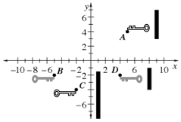
- 6-8. While solving the key challenge in Lesson 6.1.1, Rowan made more than one move to change his key from point A to point B and from point C to point D, as shown on the graph at right. Both of these keys are shown as triangles on the Lesson 6.1.2 Resource Page. Explore using the Challenge 1 Student eTool and Challenge 2 Student eTool. You may need to resize the window and reposition the grid by shift dragging. Refer to the "?" for directions using the Rigid Transformation Tool.
Your Task: With your team, describe how Rowan could have moved each key from the starting position to the ending position using slides (also called translations), turns (also called rotations), and/or flips (also called reflections).
  - Make sure you provide enough detail to describe the moves completely.
  - Try to find more than one way he could have moved each key.
  - Be ready to justify your ideas with the class.
- 6-9. WHERE DOES IT LAND?
- Felicia found a copy of a puzzle like the one in problem 6-1, but the lock is missing. All she has are the starting points and the moves to unlock the lock. This time her key is shaped like a triangle.

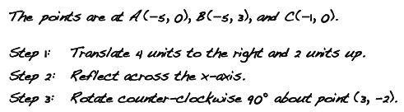
- Help Felicia find out where the lock is by following her steps. The following questions are designed to help you.
  - With your team, set up your own coordinate grid on graph paper. The questions below will help.
    - How many quadrants (regions) should the graph have? Should it be a graph with only the first quadrant? Or a graph with four quadrants?
    - How should the axes be scaled? How many units should you use for each side length of a grid square?
  - Plot triangle ABC to represent the key.
  - Follow Step 1 to translate the triangle. Name the new location of each vertex, or corner, of the triangle in the form (x, y).
  - Complete Step 2. Sketch the triangle in its new position and label the coordinates of each vertex.
  - Where does Felicia’s triangle end up? Complete Step 3 on the graph and label the coordinates of each vertex.
6-10. Now compare the triangle in problem 6-9 that you have after Step 3 with the original triangle. How do the lengths of the sides compare? How do the sizes of the angles compare?
6-11. Could Felicia’s team have used different steps to “unlock” her puzzle in problem 6-9? In other words, could she have used different moves and still have the key end up in the same final position?
  - If it is possible, list a new set of steps that would move her key from the same starting location to the same final position.
  - If it is not possible, explain why not.

