Name:
Date:
Lesson 6.1.2 Homework
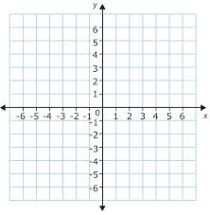
- 6-12. Graph shapes A, B, and C as described below.
  - Shape A is a triangle with vertices (1, 1), (3, 3), and (2, 4).

  - Shape B is a square with vertices (2, –1), (4, –1), (2, –3), and (4, –3).

  - Shape C is a rectangle with vertices (–3, 1), (–3, 4), (–1, 4), and (–1, 1).

6-13. On the same grid you used in problem 6-12, translate triangle A four units right and three units up to create triangle D. Write the coordinates of the new vertices.

6-14. Graph each equation below on the same set of axes and label the point of intersection with its coordinates.
y = 2x + 3 y = x + 1

6-15. Shooter Marilyn is the Spartans’ best free-throw shooter. She normally makes three out of every four shots. In an upcoming charity event, Shooter will shoot 600 free-throws. If he makes over 400 baskets, the school wins $1000. Should the Spartans expect to win the cash for the school? Show and organize your work.

6-16. Examine the tile pattern shown at right.
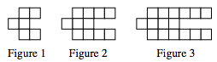
  - On graph paper, draw Figure 0 and Figure 4.
  - How many tiles will Figure 10 have? Justify your answer.

6-17. GETTING IN SHAPE
Frank weighs 160 pounds and is on a diet to gain two pounds a week so that he can make the football team. John weighs 208 pounds and is on a diet to lose three pounds a week so that he can be on the wrestling team in a lower weight class.
  - If Frank and John can meet these goals with their diets, when will they weigh the same, and how much will they weigh at that time?

  - Clearly explain your method.

