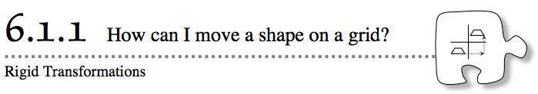
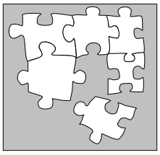
- How can you describe the movement of a figure on a flat surface when it is not moving in a straight line? For example, when you need to move a loose puzzle piece into the puzzle (as shown at right), how can you describe the way its position changes?
- Today you will explore mathematical ways of sliding, turning, and flipping an object without changing its size or shape. These types of movements are called rigid transformations. You will solve challenge problems as you explore the transformations.
- 6-1. KEY IN THE LOCK PUZZLES
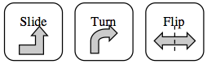
- Are you ready for a puzzle challenge? You will use the technology tool Key-Lock Transformations (Flash) or Triangle Rigid Transformations (html5). Your job will be to move the key to the keyhole to unlock the door, using the transformation buttons shown at right.
- You will need to tell the computer about how you want the key to move. For example, how far to the left or right and how far up or down do you want the key to slide? In which direction do you want your key to flip?
- Your Task: For each puzzle, move the key to the keyhole. Remember that to unlock the door, the key must fit exactly into the keyhole and not be upside down. Also note that your key will not be able to move through walls.
- Be sure to record your moves in the next column

Transformations Record Sheet
Challenge | Moves | Details
Example | Slide  Turn | Horizontal: +10 units and Vertical: +2 units  Clockwise 90° about the tip of the key
1

2

3

