Name:
Date:
Lesson 6.1.1 Homework
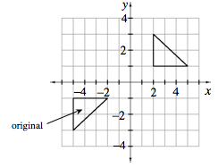
- 6-2. Describe what moves you could use to create the transformation of the original image shown at right.

- 6-3.Review what you know about graphs as you complete parts (a) through (c) below.
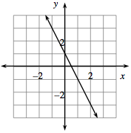
  - Find the equation of the line graphed at right.

  - What are its x- and y-intercepts?

  - On the same set of axes, graph a line that is parallel to the line graphed at right and that goes through the origin (0, 0). Find the equation of this new line.

6-4. Which equation below has no solution? Explain how you know.

  - 4(x + 1) = 2x + 4
  - 9 − 5x + 2 = 4 − 5x

6-5. Rena says that if x = −5, the equation below is true. Her friend, Dean, says the answer is x = 3. Who is correct? Justify your conclusion.
9(x + 4) = 1 + 2x

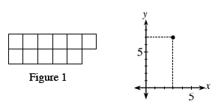
6-6. Find the rule for the pattern represented at right.

6-7. Homer the Hungry Hippo is munching on the lily pads in his pond. When he got to the pond, there were 30 lily pads, but he is eating 5 lily pads an hour. Henrietta the Hungrier Hippo found a better pond with 38 lily pads! She eats 7 lily pads every hour.
  - If Homer and Henrietta start eating at the same time, when will their ponds have the same number of lily pads remaining?

  - How many lily pads will be left in each pond at that time?

