Name:
Date:
Lesson 5.2.3 Homework
- 5-47. Ariyonne claims that (3, 6) is the point of intersection of the lines y = 4x − 2 and y = $\frac{1}{2}$x + 5. Is she correct? How do you know?

- 5-48. Graph the lines y = 2x − 3 and y = −x + 3.
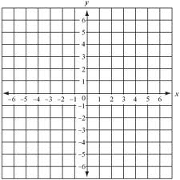
  - Where do they intersect? Label the point on the graph.

  - Find the point of intersection using the Equal Values Method. That is, start by combining both equations into one equation that you can solve for x.

  - Which method is easier, graphing or using algebra to solve?

5-49. Solve for the variable.

5-50. Graph the lines y = 2x − 3 and y = 2x + 1.
  - Where do they intersect?

  - Solve this system using the Equal Values Method.

  - Explain how your graph and algebraic solution relate to each other.

5-51. Janelle came to bat 464 times in 131 games. At this rate, how many times should she expect to have at bat in a full season of 162 games?

