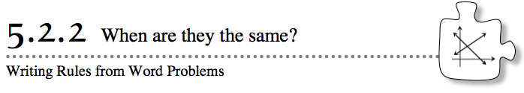
- In Lesson 5.2.1, you discovered that the point of intersection of two lines or curves can have an important meaning. Finding points of intersection is another strategy you can use to solve problems, especially those with two quantities being compared.
- Analyze the following situations using the multiple tools you have studied so far.
- 5-32. BUYING BICYCLES
- Latanya and George are saving up money because they both want to buy new bicycles. Latanya opened a savings account with $50. She just got a job and is determined to save an additional $30 a week. George started a savings account with $75. He is able to save $25 a week.
- Your Task: Use at least two different ways to find the time (in weeks) when Latanya and George will have the same amount of money in their savings accounts. Be prepared to share your methods with the class.
- 5-33. Did you graph the scenario in problem 5-32? If not, graph a line for Latanya and another line for George on the same set of axes. Confirm your answer to problem 5-32 on the graph. Consider the questions below to help you decide how to set up the graph.
  - What should the x-axis represent? What should the y-axis represent?
  - How should the axes be scaled?
  - Should the amounts in the savings accounts be graphed on the same set of axes or graphed separately? Why?
5-34. If you have not done so already, consider how to use rules to confirm the point of intersection for Latanya’s and George’s lines.
  - Write a rule for Latanya's savings account.
  - Write a rule for George's savings account.
  - Use the rules to check your solution to problem 5-34.

5-35. Gerardo decided to use tables to find the point of intersection of the lines y = 4x − 6 and y = −2x + 3. His tables are shown below.

y = 4x − 6
y = −2x + 3
  - Examine his tables. Is there a common point that makes both rules true? If not, can you describe where the point of intersection is?

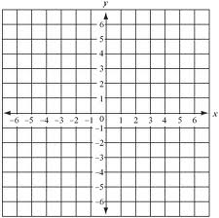
  - Now graph the rules on the same set of axes. Where do the lines intersect?

  - Use the rules to confirm your answer to part (b).

