Name:
Date:
Lesson 5.2.2 Homework
- 5-36. It is the end of the semester, and the clubs at school are recording their profits. The Science Club started out with $20 and has increased its balance by an average of $10 per week. The Math Club has saved $5 per week after starting out with $50 at the beginning of the semester.
  - Create an equation for each club. Let x represent the number of weeks and y represent the balance of the club’s account.
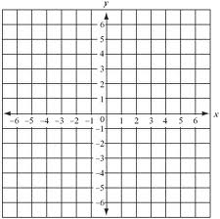
  - Graph both lines on one set of axes. When do the clubs have the same balance?

  - What is the balance at that point?

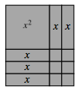
5-37. Examine the rectangle formed with algebra tiles at right.
  - Find the area of the entire rectangle. That is, what is the sum of the areas of the algebra tiles?

  - Find the perimeter of the entire rectangle. Show all work.

5-38. On graph paper, plot the points (−3, 7) and (2, −3) and draw a line through them. Then name the x- and y-intercepts of the line.

5-39. A local restaurant offers a Dim Sum lunch special that includes two dumplings, three egg rolls, a sweet bun, and a drink. Susan and her friends ordered four Dim Sum lunch specials.
How many of each item should they receive?

5-40. Solve for x.

