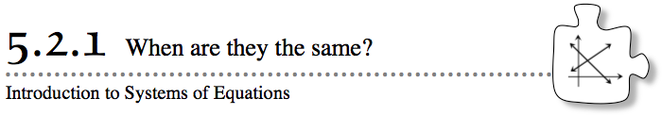
- In Section 4.1, you graphed lines and curves that represented tile patterns. But what happens when you graph two lines at the same time? What can you learn? Today you will use data, graphs, and rules to examine what happens when two lines or curves intersect.
- 5-23. The Iditarod Trail Sled Dog Race is famous for its incredible length and its use of dogs. The sled drivers, known as mushers, start their dog sleds at Fairbanks, Alaska and ride through the snow for several days until they reach Nome, Alaska. Along the route, there are stations where the competitors check in, so data is kept on the progress of each team.
- Joyla and her team of dogs have made it through the first five checkpoints. Her buddy Evie left Nome (the finish line) on the day the race started in an effort to meet Joyla and offer encouragement. Evie traveled along the route toward the racers on her snowmobile. The progress of each person is shown on the graph that follows.

- Your Task: With your team, analyze the data on the graph. Consider the questions below as you work. Be prepared to defend your results.
  - Which data represents Evie? Which represents Joyla? How can you tell?
  - When did Evie meet Joyla?
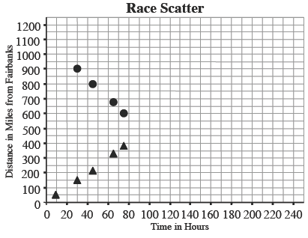
  - How long was the race? How can you tell?
  - Who traveled faster? Explain how you know.
  - Approximately how long did it take Joyla to finish the race? How did you find your answer?

5-24. The point where two lines (or curves) cross is called a point of intersection. Two or more lines (or curves) are called a system of equations. When you work with data, points of intersection can be meaningful, as you saw in the last problem.
  - On graph paper, graph y = 3x − 4 and y = −2x + 6 on the same set of axes.
  - Find the point of intersection of these two lines and label the point with its coordinates; that is, write it in the form (x, y).
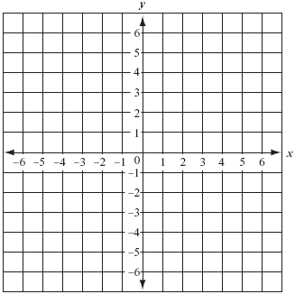
  - What is the significance of this point for the two rules in part (a)?
5-25. The meaning of a point of intersection depends on what the graph is describing. For example, in problem 5-23, the point where Joyla’s and Evie’s lines cross represents when they met during the race.
Examine each of the graphs below and write a brief story that describes the information on the graph. Include a sentence explaining what the point of intersection represents.
