Name:
Date:
Lesson 5.2.1 Homework
- 5-27. To ride to school, Elaine takes 7 minutes to ride 18 blocks. What is her unit rate (blocks per minute)? Assuming she rides at a constant speed, how long should it take her to go 50 blocks? Justify your answer.

- 5-28. Gale and Leslie are riding in a friendly 60-mile bike race that started at noon. The graph at right represents their progress so far.
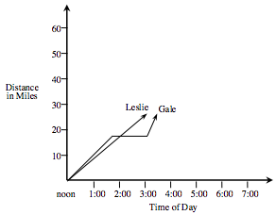
  - What does the intersection of the two lines represent?

  - At approximately what time did Leslie pass Gale?

  - About how far had Leslie traveled when she passed Gale?

  - What do you think happened to Gale between 1:30 and 3:00?

  - If Leslie continues at a steady pace, when will she complete the race?

5-29. Write an equation (rule) for each of the x→ y tables below. Then, on one set of axes, use each rule to graph.
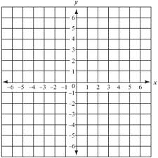
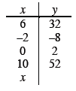
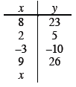

5-30. Translate each part below from symbols into words or from words into symbols.

  - −y + 8

  - 2x – 48

  - (x + 3)²

  - The opposite of six times the square of a number.

  - A number multiplied by itself, then added to five.

5-31. Solve each of the following equations for the indicated variable. Show all of your steps.

  - y = 2x − 5 for x

  - p = −3w + 9 for w

  - 2m − 6 = 4n + 4 for m

  - 3x − y = −2y for y

