Name:
Date:
Lesson 5.1.2 Homework
- 5-18. Solve each equation below.

5-19. Fisher thinks that any two lines must have a point of intersection. Is he correct? If so, explain how you know. If not, produce a counterexample and explain your reasoning. (In this case, a counterexample would be an example of two lines that do not have a point of intersection.)

5-20. In the last election, candidate B received twice as many votes as candidate A. Candidate C received 15,000 fewer votes than candidate A. If a total of 109,000 votes were cast, how many votes did candidate B receive?

5-21. Jamila wants to play a game called “Guess My Line.” She gives you the following hint: “Two points on my line are (1, 1) and (2, 4).”
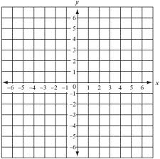
  - What is the growth rate of her line? A graph of the line may help.

  - What is the y-intercept of her line?

  - What is the equation of her line?

5-22. Solve each of the following equations. Be sure to show your work carefully and check your answers.

  - 2(3x − 4) = 22

  - 6(2x − 5) = −(x + 4)

  - 2 − (y + 2) = 3y

  - 3 + 4(x + 1) = 159

